Ansible for AWS

A simple way to provision and manage your Amazon Cloud infrastructure

# Contents

|  |  |
| --- | --- |
| **Preface**. . . . . . . . . . . . . . . . . . . . . . . . . . . . . . . . . . . . . . . . . . . . . . . | **i** |
| What this book covers . . . . . . . . . . . . . . . . . . . . . . . . . . . . . . . . . . . . . | ii |
| Who this book is for . . . . . . . . . . . . . . . . . . . . . . . . . . . . . . . . . . . . . . | iii |
| What you need for this book . . . . . . . . . . . . . . . . . . . . . . . . . . . . . . . . . | iii |
| Conventions . . . . . . . . . . . . . . . . . . . . . . . . . . . . . . . . . . . . . . . . . . | iii |
| Example Code Files . . . . . . . . . . . . . . . . . . . . . . . . . . . . . . . . . . . . . . | iv |
| **Chapter 1: Getting Started with AWS**. . . . . . . . . . . . . . . . . . . . . . . . . . . . . . | **1** |
| What is Amazon Web Services (AWS)? . . . . . . . . . . . . . . . . . . . . . . . . . . . . | 1 |
| Setting Up Your AWS Account . . . . . . . . . . . . . . . . . . . . . . . . . . . . . . . . | 7 |
| AWS Management Console . . . . . . . . . . . . . . . . . . . . . . . . . . . . . . . . . . | 12 |
| Create Your First EC2 Instance . . . . . . . . . . . . . . . . . . . . . . . . . . . . . . . . | 16 |
| Connect to Your Instance . . . . . . . . . . . . . . . . . . . . . . . . . . . . . . . . . . . | 26 |
| Terminate Your Instance . . . . . . . . . . . . . . . . . . . . . . . . . . . . . . . . . . . . | 28 |
| **Chapter 2: Getting Started with Ansible**. . . . . . . . . . . . . . . . . . . . . . . . . . . . | **30** |
| What You’ll Need . . . . . . . . . . . . . . . . . . . . . . . . . . . . . . . . . . . . . . . | 30 |
| Installing Ansible . . . . . . . . . . . . . . . . . . . . . . . . . . . . . . . . . . . . . . . | 31 |
| SSH Keys . . . . . . . . . . . . . . . . . . . . . . . . . . . . . . . . . . . . . . . . . . . . | 32 |
| Inventory . . . . . . . . . . . . . . . . . . . . . . . . . . . . . . . . . . . . . . . . . . . . | 33 |
| Your First Commands . . . . . . . . . . . . . . . . . . . . . . . . . . . . . . . . . . . . . | 38 |
| Playbooks . . . . . . . . . . . . . . . . . . . . . . . . . . . . . . . . . . . . . . . . . . . | 39 |
| Your First Playbook . . . . . . . . . . . . . . . . . . . . . . . . . . . . . . . . . . . . . . | 45 |
| Roles and Include Statements . . . . . . . . . . . . . . . . . . . . . . . . . . . . . . . . . | 47 |
| **Chapter 6: VPC Provisioning with Ansible**. . . . . . . . . . . . . . . . . . . . . . . . . . . | **49** |
| The Default VPC . . . . . . . . . . . . . . . . . . . . . . . . . . . . . . . . . . . . . . . . | 49 |
| Getting Started with VPC . . . . . . . . . . . . . . . . . . . . . . . . . . . . . . . . . . . | 51 |
| VPC Provisioning . . . . . . . . . . . . . . . . . . . . . . . . . . . . . . . . . . . . . . . | 62 |
| VPC Security Groups . . . . . . . . . . . . . . . . . . . . . . . . . . . . . . . . . . . . . | 67 |
| EC2-VPC Provisioning . . . . . . . . . . . . . . . . . . . . . . . . . . . . . . . . . . . . . | 73 |
| NAT Instance . . . . . . . . . . . . . . . . . . . . . . . . . . . . . . . . . . . . . . . . . . | 75 |
| Multi-AZ Deployment . . . . . . . . . . . . . . . . . . . . . . . . . . . . . . . . . . . . . | 79 |
| Ansible in VPC . . . . . . . . . . . . . . . . . . . . . . . . . . . . . . . . . . . . . . . . . | 82 |

CONTENTS

OpenVPN Server 88

Getting VPC and Subnet ID 94

# Preface

Since the [CFEngine](https://cfengine.com/)¹ project by Mark Burgess began in 1993, configuration management tools have been revolutionizing IT operations. Followed by the emergence of [Puppet](https://puppetlabs.com/)² and [Chef](http://www.getchef.com/)³, which later gain more popularity, there are now many choices available to do IT automation. The new generation of configuration management tools can build servers in seconds and automate your entire infrastructure.

[Ansible](http://www.ansible.com/)⁴, first released in 2012, is one of the newer tools in the IT automation space. While other tools like Puppet and Chef focused on completeness and configurability, Ansible focused on simplicity and low learning curve, without sacrificing security and reliability.

Amazon Web Services (AWS) began offering IT infrastructure services to businesses in 2006, in the form of web services – now commonly known as cloud computing. One of the key benefits of cloud computing is the opportunity to replace up-front capital infrastructure expenses with low variable costs that scale with your business. With the Cloud, businesses no longer need to plan for and procure servers and other IT infrastructure weeks or months in advance. Instead, they can instantly spin up hundreds or thousands of servers in minutes and deliver results faster.⁵

This book will show you how to use Ansible’s cloud modules to easily provision and manage AWS resources including **EC2**, **VPC**, **RDS**, **S3**, **ELB**, **Auto Scaling**, **IAM** and **Route 53**. This book takes you beyond the basics of Ansible, showing you real-world examples of AWS infrastructure automation and management using Ansible, with detailed steps, complete codes, and screen captures from AWS console.

The example projects will help you grasp the concepts quickly. From a single WordPress site, to a highly available and scalable WordPress site, Ansible will help you automate all tasks.

## What this book covers

### You’ll find the following chapters in this book:

*Chapter 1, Getting Started with AWS*, shows you how to sign up for AWS (Amazon Web Services), set up your account, get familiar with AWS console, create your first Amazon EC2 (Elastic Compute Cloud) instance, and connect to your EC2 instance using SSH.

*Chapter 2, Getting Started with Ansible*, teaches you the basics of Ansible, how to build an inventory, how to use modules, and create Ansible playbooks to manage your hosts.

*Chapter 3, EC2 Provisioning and Configuration Management with Ansible*, teaches you how to use Ansible playbook to configure and launch EC2 instances, and use dynamic inventory to manage EC2 instances.

*Chapter 4, Project 1 - A WordPress Site* gives you an example project to provision a simple WordPress site in AWS cloud.

*Chapter 5, Route 53 Management with Ansible* teaches you how to create and delete Domain Name System (DNS) records in Amazon Route 53 DNS web service using Ansible.

*Chapter 6, VPC Provisioning with Ansible*, delves deeper into AWS cloud infrastructure and teaches you how to use Ansible to create and manage Virtual Private Cloud (VPC), VPC subnets, VPC routing tables, and VPC Security Groups, also how to use Ansible to launch EC2 instances in VPC subnet and attach VPC security groups to the instances.

*Chapter 7, RDS Provisioning with Ansible*, teaches you how to use Ansible to provision Amazon Relational Database Service (RDS), replicate RDS database, take snapshot, and restore backup.

*Chapter 8, S3 Management with Ansible*, teaches you how to manage files in an Amazon Simple Storage Service (S3) bucket using Ansible.

*Chapter 9, Using AWS CLI with Ansible* shows you how to use AWS CLI to extend Ansible functionality in AWS environment.

*Chapter 10, Project 2 - A Multi-Tier WordPress Site*, an example project to build a highly available and scalable WordPress site.

*Chapter 11, Amazon Machine Images (AMI)*, teaches you how to create AMI from an EC2 instance.

*Chapter 12, Auto Scaling and Elastic Load Balancing (ELB)*, introduces you to Elastic Load Balancing and Auto Scaling.

*Chapter 13, ELB and Auto Scaling with Ansible*, teaches you how to use Ansible to provision ELB and Auto Scaling Groups.

*Chapter 14, Identity and Access Management (IAM)*, shows you how to use Ansible to manage IAM users, groups, roles and keys.

## Who this book is for

The book assumes that the reader has a little experience of Linux systems administration, including familiarity with the command line, file system, and text editing. It is expected that the reader has basic knowledge of Amazon Web Services and a little experience of Ansible usage.

## What you need for this book

To run the examples in this book, you will need a computer with Linux operating system and an Internet connection. To use the services in Amazon Web Services, you will need to setup an account and register your credit card with Amazon.

## Conventions

In this book, you will find a number of styles of text that distinguish between different kinds of information. Here are some examples of these styles, and an explanation of their meaning.

Code words in text are shown as follow: “We can include other contexts through the use of the

include directive.”

A block of code is set as follows:

1. [group]
2. host1
3. host2
4. host3

Any command-line input is written as follows:

$ ansible-playbook -i hosts site.yml

## This is an information box

Special information appear in a box like this

## This is a warning box

Warnings appear in a box like this

## Tips and tricks

ips and tricks appear like this

# Chapter 1: Getting Started with AWS

This chapter will give you introduction to Amazon Web Services (AWS), show you how to set up your AWS account, create your first EC2 instance, and connect to your EC2 instance using SSH. You can skip this chapter if you already have an AWS account and experience with EC2 instance.

## What is Amazon Web Services (AWS)?

Amazon Web Services (AWS) provides computing resources and services that you can use to build applications within minutes at pay-as-you-go pricing. For example, you can rent a server on AWS that you can connect to, configure, secure, and run just as you would a physical server. The difference is the virtual server runs on top of a planet-scale network managed by AWS.

You pay for your virtual server only while it runs, with no up-front purchase costs or ongoing maintenance costs. Backed by the AWS network, your virtual server can do things no physical server can, such as automatically scaling into multiple servers when demand for your application increases.

Using AWS to build your Internet application is like purchasing electricity from a power company instead of running your own generator, and it provides many of the same benefits: capacity exactly matches your need, you pay only for what you use, economies of scale result in lower costs, and the service is provided by a vendor experienced in running large-scale networks. In addition, AWS can offer significant cost savings, up to 80%, compared to the equivalent on-premises deployments.

You can run nearly anything on AWS that you would run on physical hardware: websites, applications, databases, mobile apps, email campaigns, distributed data analysis, media storage, and private networks. The services we provide are designed to work together so that you can build complete solutions. There are currently dozens of services, with more being added each year.⁷

The following diagram shows the categories of functionality offered by AWS.

⁷[Getting Started with AWS](http://docs.aws.amazon.com/gettingstarted/latest/awsgsg-intro/gsg-aws-intro.html)

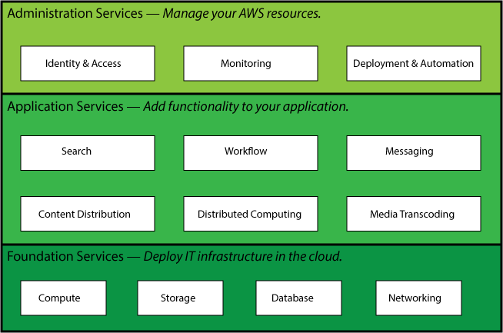

**AWS Functionality**

In each category, there are one or more services. For example, AWS offers five database services, each one optimized for a certain type of use. With so many offerings, you can design an AWS solution that is tailored to your needs.

Amazon has produced a set of short videos to help you understand AWS basics:

* [What is Cloud Computing](http://youtu.be/jOhbTAU4OPI)⁸
* [What is Amazon Web Services](http://youtu.be/mZ5H8sn_2ZI)⁹

In this book we will only use following AWS services from Foundation Services category:

* **EC2** (Elastic Compute Cloud)
* **VPC** (Virtual Private Cloud)
* **RDS** (Relational Database Service)
* **S3** (Simple Storage Service)
* **ELB** (Elastic Load Balancing)

#### Auto Scaling

* **Route 53**

⁸<http://youtu.be/jOhbTAU4OPI>

⁹<http://youtu.be/mZ5H8sn_2ZI>

### EC2 (Elastic Compute Cloud)



**EC2**

Amazon Elastic Compute Cloud (Amazon EC2) is a web service that provides resizable compute capacity in the cloud. It is designed to make web-scale computing easier for developers.

Amazon EC2’s simple web service interface allows you to obtain and configure capacity with minimal friction. It provides you with complete control of your computing resources and lets you run on Amazon’s proven computing environ- ment. Amazon EC2 reduces the time required to obtain and boot new server

instances to minutes, allowing you to quickly scale capacity, both up and down, as your computing requirements change. Amazon EC2 changes the economics of computing by allowing you to pay only for capacity that you actually use. Amazon EC2 provides developers the tools to build failure resilient applications and isolate themselves from common failure scenarios.¹⁰

### VPC (Virtual Private Cloud)



**VPC**

Amazon Virtual Private Cloud (Amazon VPC) lets you provision a logically isolated section of the Amazon Web Services (AWS) Cloud where you can launch AWS resources in a virtual network that you define. You have complete control over your virtual networking environment, including selection of your own IP address range, creation of subnets, and configuration of route tables and network gateways.

You can easily customize the network configuration for your Amazon VPC. For

example, you can create a public-facing subnet for your webservers that has access to the Internet, and place your backend systems such as databases or application servers in a private-facing subnet with no Internet access. You can leverage multiple layers of security, including security groups and network access control lists, to help control access to Amazon EC2 instances in each subnet.¹¹

### RDS (Relational Database Service)



**RDS**

Amazon Relational Database Service (Amazon RDS) is a web service that makes it easy to set up, operate, and scale a relational database in the cloud. It provides cost-efficient and resizable capacity while managing time-consuming database administration tasks, freeing you up to focus on your applications and business.

Amazon RDS gives you access to the capabilities of a familiar MySQL, Oracle, Microsoft SQL Server, or PostgreSQL database engine. This means that the code, applications, and tools you already use today with your existing databases can

be used with Amazon RDS. Amazon RDS automatically patches the database software and backs up

¹⁰<http://aws.amazon.com/ec2>

¹¹<http://aws.amazon.com/vpc>

your database, storing the backups for a user-defined retention period and enabling point-in-time recovery. You benefit from the flexibility of being able to scale the compute resources or storage capacity associated with your Database Instance (DB Instance) via a single API call.¹²

### S3 (Simple Storage Service)



**S3**

developers.

Amazon S3 is storage for the Internet. It is designed to make web-scale computing easier for developers.

Amazon S3 provides a simple web-services interface that can be used to store and retrieve any amount of data, at any time, from anywhere on the web. It gives any developer access to the same highly scalable, reliable, secure, fast, inexpensive infrastructure that Amazon uses to run its own global network of web sites. The service aims to maximize benefits of scale and to pass those benefits on to

Amazon S3 provides a highly durable and available store for a variety of content, ranging from web applications to media files. It allows you to offload your entire storage infrastructure onto the cloud, where you can take advantage of Amazon S3’s scalability and pay-as-you-go pricing to handle your growing storage needs. You can distribute your content directly from Amazon S3 or use Amazon S3 as an origin store for pushing content to your Amazon CloudFront edge locations.¹³

### ELB (Elastic Load Balancing)



**ELB**

Elastic Load Balancing automatically distributes incoming application traffic across multiple Amazon EC2 instances.

It enables you to achieve greater levels of fault tolerance in your applications, seamlessly providing the required amount of load balancing capacity needed to distribute application traffic.

Elastic Load Balancing automatically scales its request handling capacity to meet

the demands of application traffic. Additionally, Elastic Load Balancing offers integration with Auto Scaling to ensure that you have back-end capacity to meet varying levels of traffic levels without requiring manual intervention.¹⁴

¹²<http://aws.amazon.com/rds>

¹³<http://aws.amazon.com/s3>

¹⁴<http://aws.amazon.com/elasticloadbalancing>

### Route 53



**Route53**

Amazon Route 53 is a highly available and scalable Domain Name System (DNS) web service. It is designed to give developers and businesses an extremely reliable and cost effective way to route end users to Internet applications by translating names like [www.example.com](http://www.example.com/) into the numeric IP addresses like 192.0.2.1 that computers use to connect to each other.

Route 53 effectively connects user requests to infrastructure running in AWS – such as Amazon EC2 instances, Elastic Load Balancers, or Amazon S3 buckets –

and can also be used to route users to infrastructure outside of AWS.

Route 53 is designed to be fast, easy to use, and cost-effective. It answers DNS queries with low latency by using a global network of DNS servers. Queries for your domain are automatically routed to the nearest DNS server, and thus answered with the best possible performance. With Route 53, you can create and manage your public DNS records with the AWS Management Console or with an easy-to-use API. It’s also integrated with other Amazon Web Services. For instance, by using the AWS Identity and Access Management (IAM) service with Route 53, you can control who in your organization can make changes to your DNS records. Like other Amazon Web Services, there are no long-term contracts or minimum usage requirements for using Route 53 – you pay only for managing domains through the service and the number of queries that the service answers.¹⁵

¹⁵<http://aws.amazon.com/route53>

## AWS Global Infrastructure

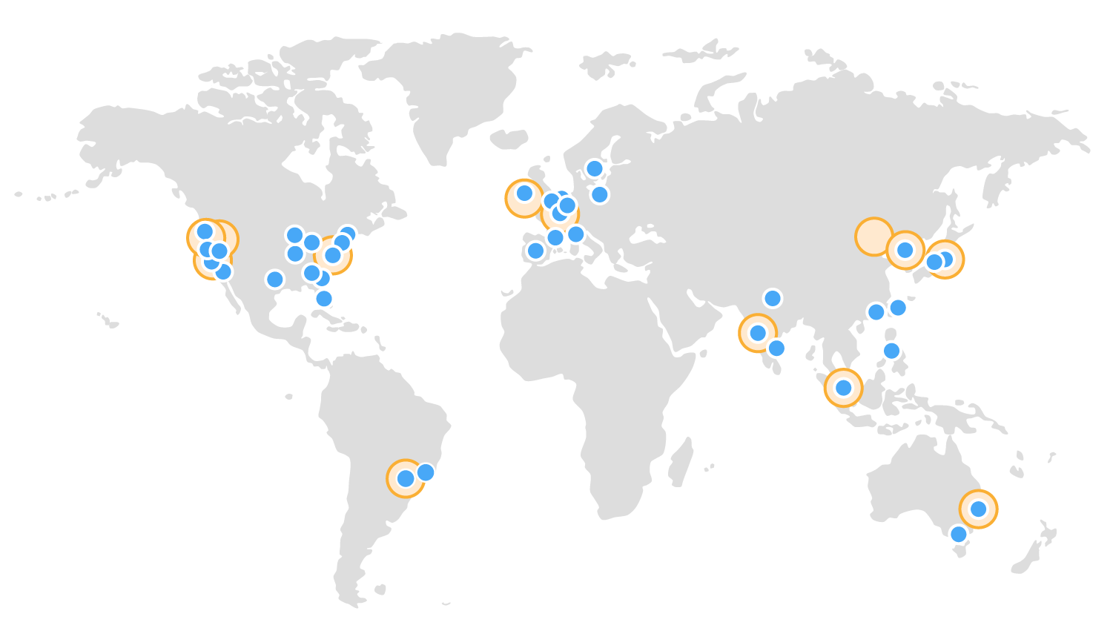Whether you are a large global company or small start-up, you may have potential customers around the world. With traditional infrastructure, it’s hard to deliver great per- formance to a broadly distributed user base and most companies focus on one geographic region at a time to save costs and time. With Cloud Computing, the game changes - you can easily deploy your application in any or all of the AWS regions around the world. This means you can provide a lower latency and better experience for your customers at minimal cost.¹⁶

[See detailed list of offerings at all AWS locations](http://aws.amazon.com/about-aws/globalinfrastructure/regional-product-services)¹⁷

¹⁶<http://aws.amazon.com/what-is-cloud-computing/#global-reach>

¹⁷<http://aws.amazon.com/about-aws/globalinfrastructure/regional-product-services>

## Setting Up Your AWS Account

If you don’t already have an Amazon Web Services account, open your web browser on your computer and go to [http://aws.amazon.com](http://aws.amazon.com/). Follow the steps below:

1. Click the **Sign In to the Console** button

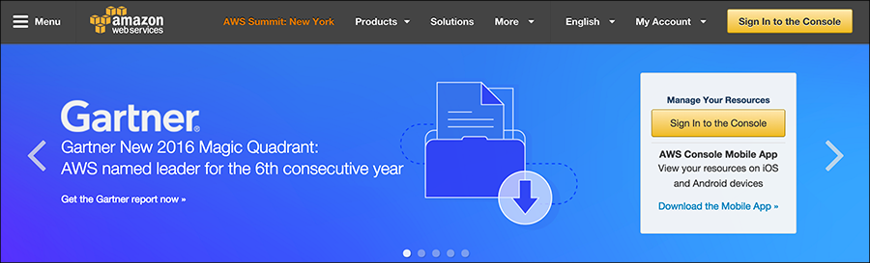

1. On the next screen, select the **I am a new user** radio button, fill in your e-mail address in the given field, and then click the **Sign in using our secure server** button

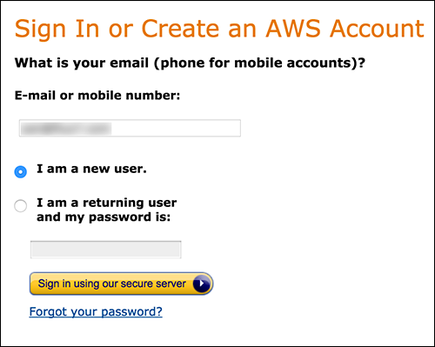

Technically, if you have Amazon retail account, you can sign in using your Amazon.com account, but it is recommended that you set up a new AWS account.

1. On the next page, enter your name, type your e-mail address again, and enter your password (twice), then click **Create account** button

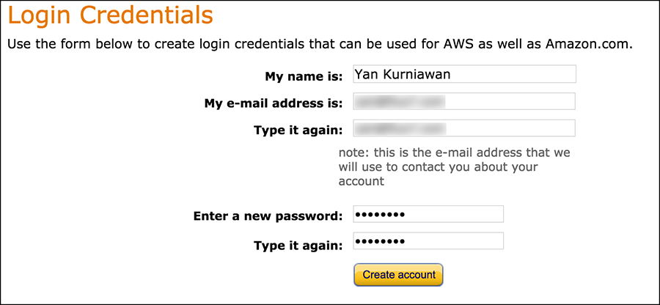

1. On the next screen, select **Personal Account** (or **Company Account** if you want to create an AWS account for your company), enter the required information on the **Contact Information** form, type the **Security Check** characters, confirm your acceptance of the AWS customer agreement, and then click the **Securely Submit** button.

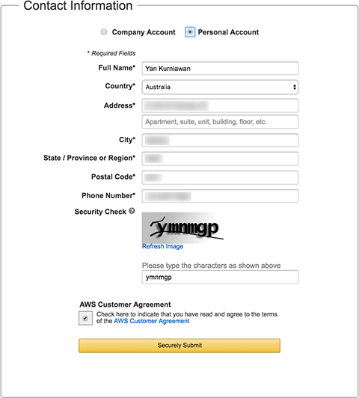

1. The next page asks you for a credit card number and your billing address information. Enter the required information and click **Continue** button.

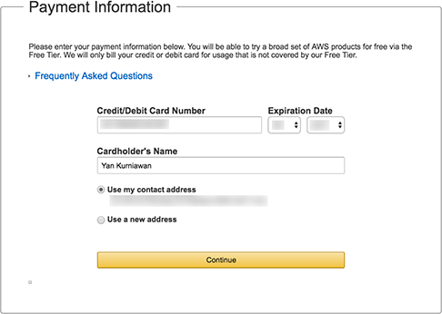

1. 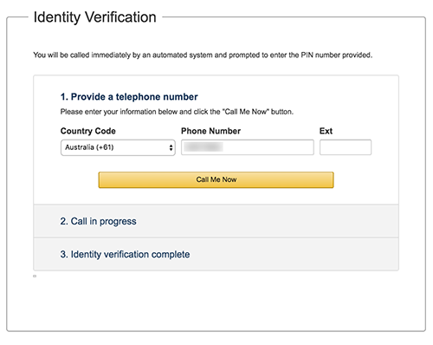On the next page, Amazon wants to confirm your identity. Enter your valid phone or mobile number and click the **Call Me Now** button.

Answer the phone and enter the displayed PIN code on the telephone keypad, or you can say the PIN numbers.

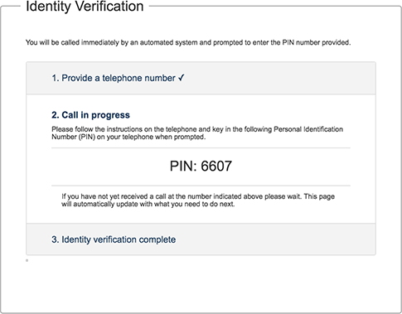

After the identity verification completed successfully, click the **Continue to select your Support Plan** button.

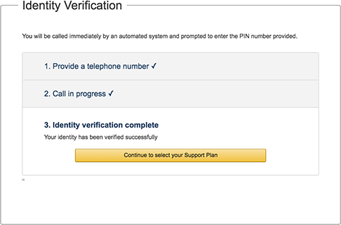

1. On the next page, choose your support plan and click the **Continue** button.

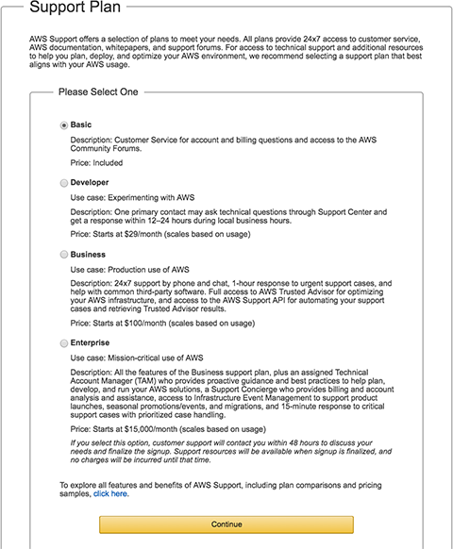

1. Setup is now complete, you’ll get an e-mail confirming your account setup.

**You have given AWS your credit card information to pay for the resources you use.** Be careful about how much AWS resource you use and try to understand the pricing scheme for each service.

[EC2 Pricing Scheme](http://aws.amazon.com/ec2/pricing)¹⁸ [S3 Pricing Scheme](http://aws.amazon.com/s3/pricing)¹⁹

Your initial account sign-up provides free usage tier for a year. For a complete list of services that you can use for free, check out [AWS Free Usage Tier](http://aws.amazon.com/free)²⁰ page.

Amazon provides an [online calculator](http://calculator.s3.amazonaws.com/index.html)²¹ to estimate your monthly AWS bill.

¹⁸<http://aws.amazon.com/ec2/pricing>

¹⁹<http://aws.amazon.com/s3/pricing>

²⁰<http://aws.amazon.com/free>

²¹<http://calculator.s3.amazonaws.com/index.html>

## AWS Management Console

Amazon provides a web-based AWS Management Console. You can access and manage Amazon Web Services resources through a simple and intuitive web-based user interface. The AWS Manage- ment Console is a single destination for managing all your AWS resources, from EC2 instances to DynamoDB tables. Use the Console to perform any number of tasks, from deploying new applications to monitoring the health of your application.

The AWS Management Console also enables you to manage all aspects of your AWS account, including accessing your monthly spending by service, managing security credentials, or even setting up new IAM Users.

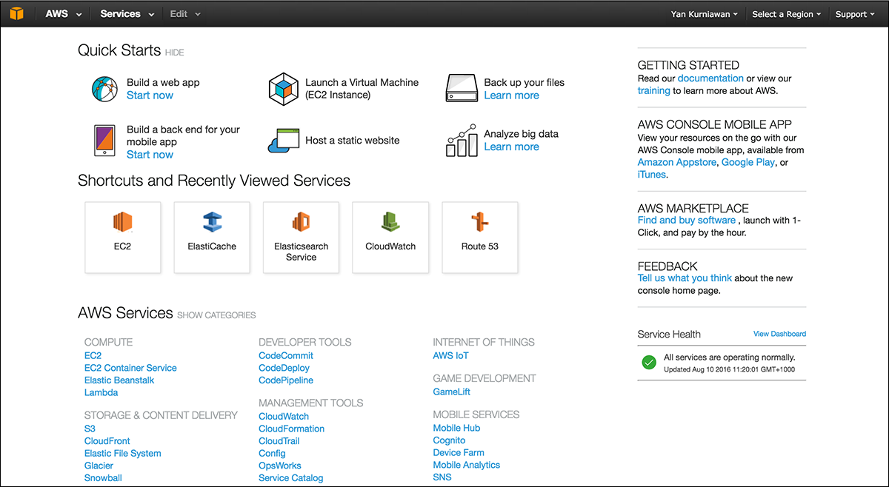

**The Console Home**

To see your monthly billing, you can choose **Billing & Cost Management** from the pull down menu under your account name on top right of the page.

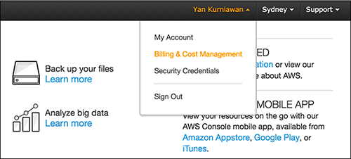

**Billing and Cost Management**

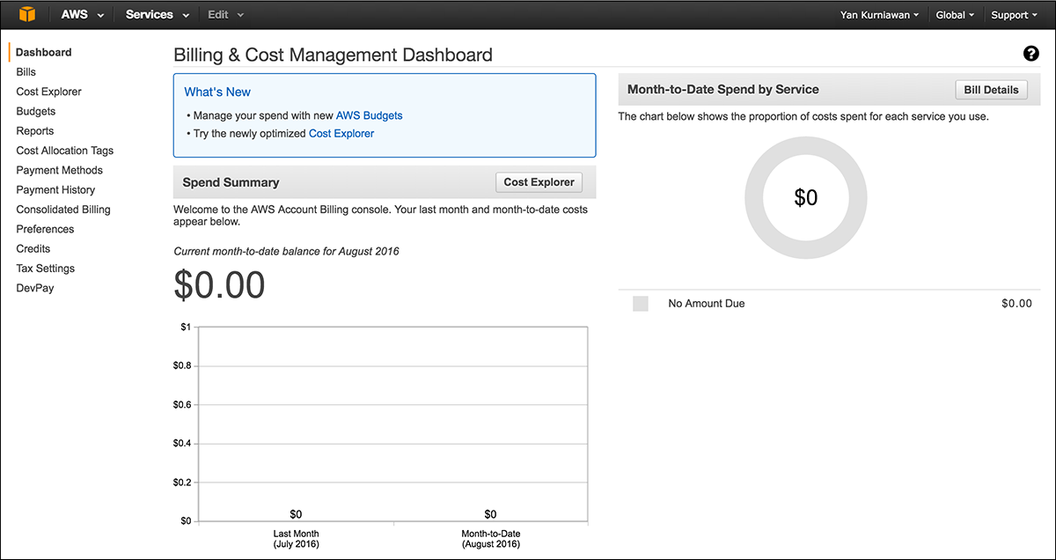

**The Billing Dashboard**

You can customize one-click navigation on the menu bar. Click on the **Edit** pull down menu and drag your selected service to/from the menu bar.

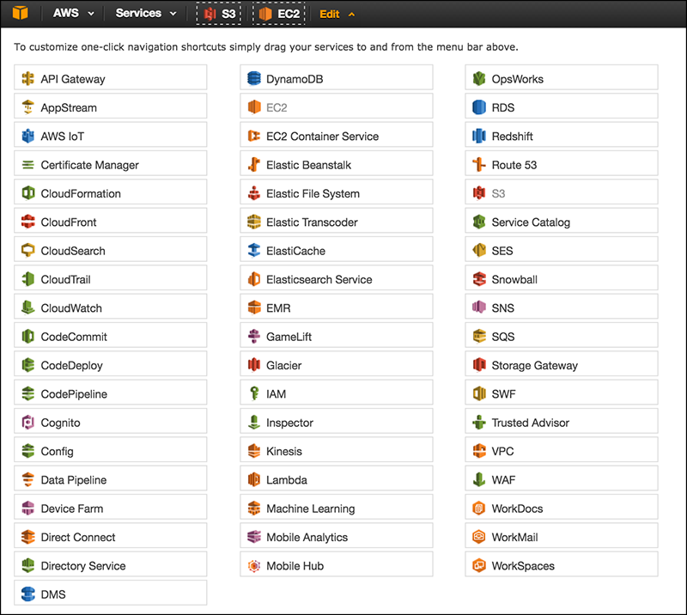

**Customize One-click Navigation**

Each service has its own console, which you can access from the AWS Management Console.

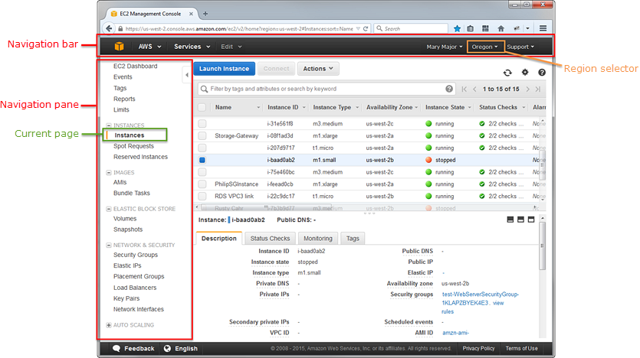

**EC2 Console**

For a complete guide to AWS Management Console, visit [AWS Management Console](http://docs.aws.amazon.com/awsconsolehelpdocs/latest/gsg/getting-started.html) [Getting Started Guide](http://docs.aws.amazon.com/awsconsolehelpdocs/latest/gsg/getting-started.html)²² page.

²²<http://docs.aws.amazon.com/awsconsolehelpdocs/latest/gsg/getting-started.html>

## Create Your First EC2 Instance

EC2 - the Elastic Compute Cloud, is the most widely used AWS service. EC2 is the most revolutionary of the AWS services because it has transformed the way of provisioning servers. EC2 provides virtual servers in a matter of minutes with a few clicks on the AWS Management Console.

Let’s create our first EC2 instance.

### Create a Key Pair

First, we need to create a key pair. AWS uses public-key cryptography to secure the login information for your instance. A Linux instance has no password; you use a key pair to log in to your instance securely. You specify the name of the key pair when you launch your instance, then provide the private key when you log in. Key pairs are specific to a region; for example, if you plan to launch an instance in the Asia Pacific (Sydney) Region, you must create a key pair for the instance in the Asia Pacific (Sydney) Region.

#### To create a key pair

1. Open the Amazon EC2 Dashboard <https://console.aws.amazon.com/ec2>
2. From the navigation bar, select a region for the key pair.

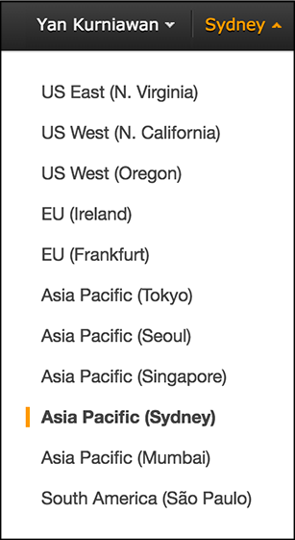

1. Click **Key Pairs** in the navigation pane.

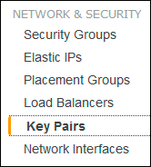

1. Click **Create Key Pair**

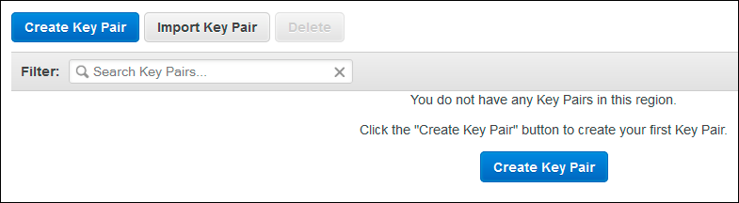

1. Enter a name for the new key pair in the **Key pair name** field of the **Create Key Pair** dialog box, and then click **Create**. Choose a name that is easy for you to remember, such as your name, followed by -key-pair, plus the region name. For example, yan-key-pair-apsydney.

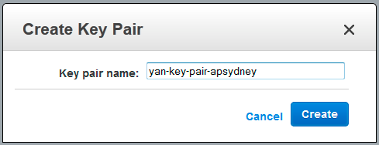

1. If you use Google Chrome as your browser, the private key file is automatically downloaded by your browser. The base file name is the name you specified as the name of your key pair, and the file name extension is .pem. If you use Firefox, the browser might ask you to Open/Save the file. Save the private key file in a safe place.

#### Important

This is the only chance for you to save the private key file. You’ll need to provide the name of your key pair when you launch an instance and the corresponding private key each time you connect to the instance.

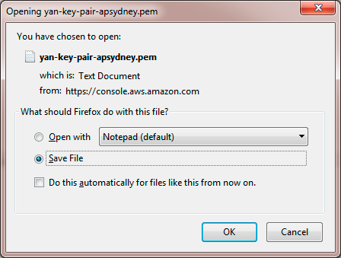

1. If you will use an SSH client on a Mac or Linux computer to connect to your Linux instance, use the chmod command to set the permissions of your private key file so that only you can read it.

$ chmod 400 yan-key-pair-apsydney.pem

If you’ll connect to your Linux instance from a computer running Windows, you can use PuTTY or MindTerm. If you use PuTTY, you’ll need to install it and use the following procedure to convert the .pem file to a .ppk file.

#### To prepare to connect to a Linux instance from Windows using PuTTY

1. Download and install PuTTY from <http://www.chiark.greenend.org.uk/~sgtatham/putty>. Be sure to install the entire suite (Download the installer file under **A Windows installer for everything except PuTTYtel** section).
2. Start **PuTTYgen** (for example, from the **Start** menu, click **All Programs > PuTTY > PuTTYgen**).
3. Under **Type of key to generate**, select **SSH-2 RSA**.

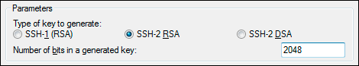

1. Click **Load**. By default, PuTTYgen displays only files with the extension .ppk. To locate your

.pem file, select the option to display files of all types.

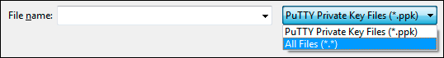

1. Select the private key file that you created in the previous procedure and click **Open**. Click OK to dismiss the confirmation dialog box.

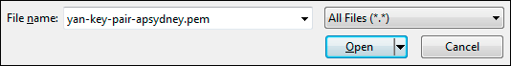

1. Click **Save private key**. PuTTYgen displays a warning about saving the key without a passphrase. Click **Yes**.
2. Specify the same name for the key that you used for the key pair. PuTTY automatically adds the .ppk file extension.

### Create a Security Group

Security groups act as a firewall for associated instances, controlling both inbound and outbound traffic at the instance level. You must add rules to a security group that enable you to connect to your instance from your IP address using SSH. You can also add rules that allow inbound and outbound HTTP and HTTPS access from anywhere.

Note that if you plan to launch instances in multiple regions, you’ll need to create a security group in each region.

You’ll need the public IP address of your local computer, which you can get using a service from Amazon AWS [http://checkip.amazonaws.com](http://checkip.amazonaws.com/). If you are connecting through an Internet service provider (ISP) or from behind a firewall without a static IP address, you need to find out the range of IP addresses used by client computers.

#### To create a security group

1. Open the Amazon EC2 Dashboard <https://console.aws.amazon.com/ec2>
2. From the navigation bar, select a region for the security group. Security groups are specific to a region; for example, if you plan to launch an instance in the Asia Pacific (Sydney) Region, you must create a security group for the instance in the Asia Pacific (Sydney) Region.
3. Click **Security Groups** in the navigation pane.

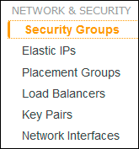

1. Click **Create Security Group**.

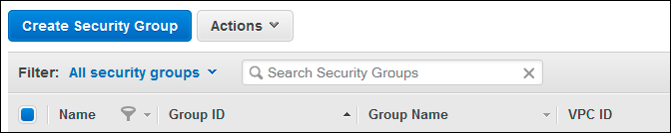

1. Enter a name for the new security group and a description. Choose a name that is easy for you to remember, such as SG_ plus the region name. For example, SG_apsydney.

On the **Inbound** tab, create the following rules (click **Add Rule** for each new rule), and click

**Create** when you’re done:

* + Select **HTTP** from the **Type** list, and make sure that **Source** is set to **Anywhere**

(0.0.0.0/0).

* + Select **HTTPS** from the **Type** list, and make sure that **Source** is set to **Anywhere**

(0.0.0.0/0).

* + Select **SSH** from the **Type** list. In the **Source** box, ensure **Custom IP** is selected, and specify the public IP address of your computer or network in CIDR notation. To specify an individual IP address in CIDR notation, add the routing prefix /32. For example, if your IP address is 203.0.100.2, specify 203.0.100.2/32. If your company allocates addresses from a range, specify the entire range, such as 203.0.100.0/24.

#### Caution

For security reasons, Amazon doesn’t recommend that you allow SSH access from all IP addresses (0.0.0.0/0) to your instance, except for testing purposes and only for a short time.

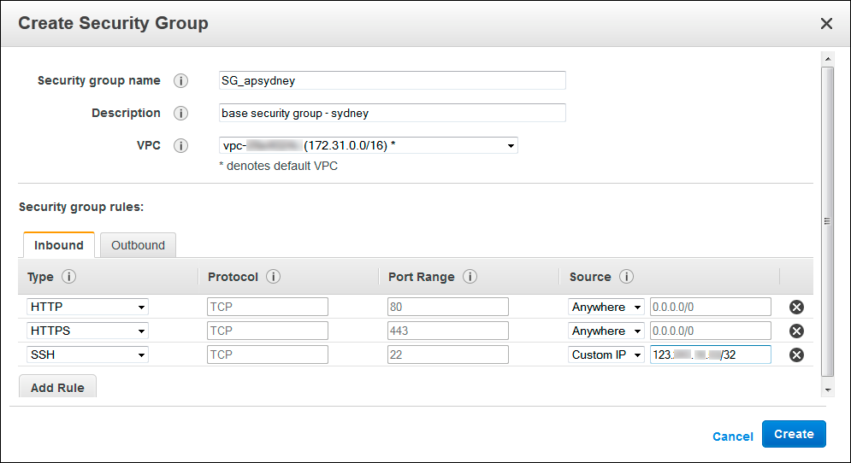

**Create Security Group**

You can select **My IP** in the **Source** box to allow traffic from your IP address.

The following procedure is intended to help you launch your first instance quickly and doesn’t go through all possible options. For more information about the advanced options see [AWS](http://docs.aws.amazon.com/AWSEC2/latest/UserGuide/launching-instance.html) [Documentation on Launching an Instance](http://docs.aws.amazon.com/AWSEC2/latest/UserGuide/launching-instance.html)²³.

#### To launch an instance

1. Open the Amazon EC2 Dashboard <https://console.aws.amazon.com/ec2>.
2. From the console dashboard, click **Launch Instance**.

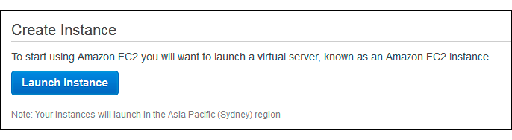

²³<http://docs.aws.amazon.com/AWSEC2/latest/UserGuide/launching-instance.html>

1. 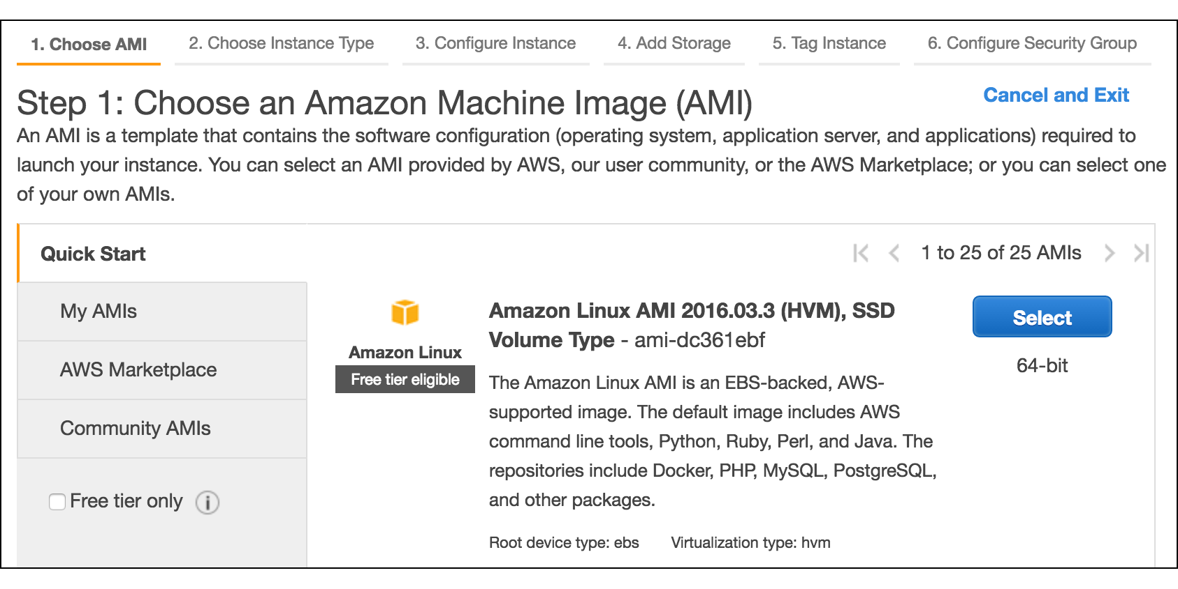The **Choose an Amazon Machine Image (AMI)** page displays a list of basic configurations called Amazon Machine Images (AMIs) that serve as templates for your instance. Select the 64-bit Amazon Linux AMI. Notice that this configuration is marked “Free tier eligible”. Click the **Select** button.
2. On the **Choose an Instance Type** page, you can select the hardware configuration of your instance. The t2.micro (or t1.micro, depends on the AMI virtualization type) instance is selected by default. Click **Review and Launch** to let the wizard complete other configuration settings for you, so you can get started quickly.

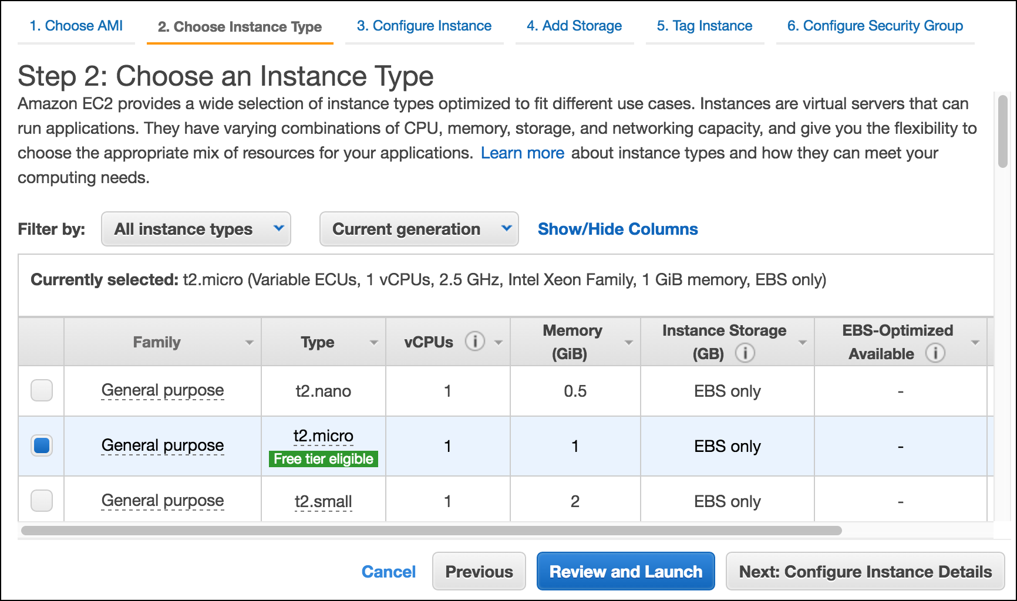

1. On the **Review Instance Launch** page, you can review the settings for your instance.

Under **Security Groups**, you’ll see that the wizard created and selected a security group for you. Instead, select the security group that you created when getting set up using the following steps:

* + Click **Edit security groups**.
  + On the **Configure Security Group** page, ensure the **Select an existing security group**

option is selected.

* + 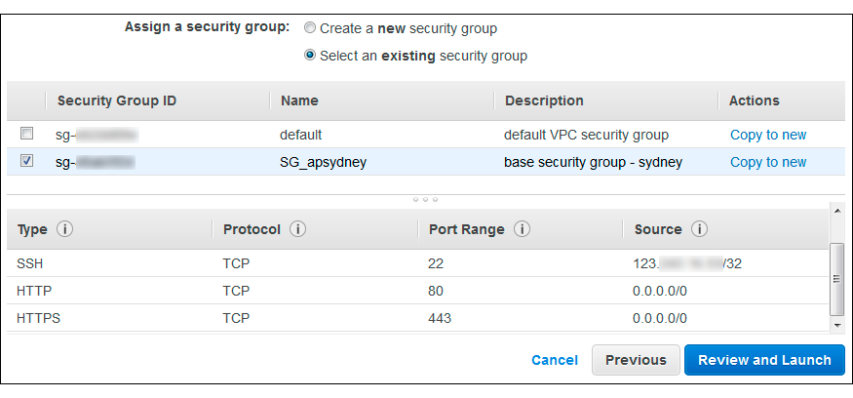Select your security group from the list of existing security groups, and click **Review and Launch**.

1. On the **Review Instance Launch** page, click **Launch**.
2. In the **Select an existing key pair or create a new key pair** dialog box, select **Choose an existing key pair**, then select the key pair you created when getting set up. Select the acknowledgment check box, and then click **Launch Instances**.

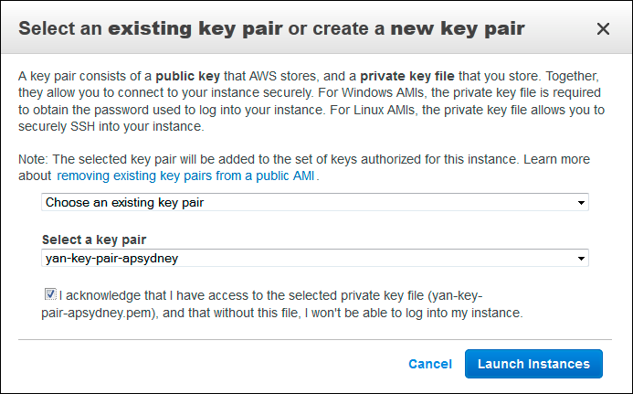

1. A confirmation page lets you know that your instance is launching. Click **View Instances** to close the confirmation page and return to the console.
2. On the **Instances** screen, you can view the status of your instance. It takes a short time for an instance to launch. When you launch an instance, its initial state is pending. After the instance starts, its state changes to running, and it receives a public DNS name. (If the **Public DNS** column is hidden, click the **Show/Hide** icon and select **Public DNS**).

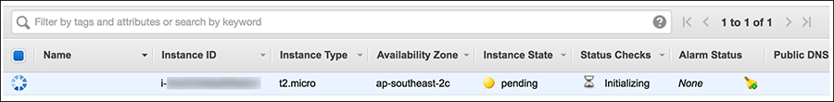

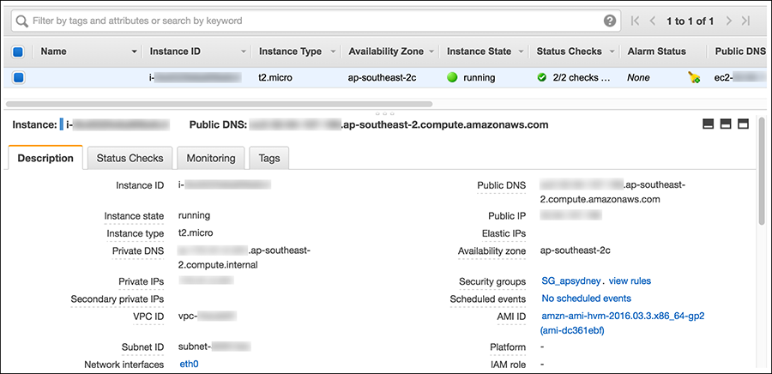

To learn more about Amazon EC2 instance type, see [http://docs.aws.amazon.com/](http://docs.aws.amazon.com/AWSEC2/latest/UserGuide/instance-types.html) [AWSEC2/latest/UserGuide/instance-types.html](http://docs.aws.amazon.com/AWSEC2/latest/UserGuide/instance-types.html)

## Connect to Your Instance

If your computer uses Windows operating system, you will need to install PuTTY to connect to your Linux EC2 instance.

#### To connect to your Linux instance using PuTTY

1. Start PuTTY (from the **Start** menu, click **All Programs > PuTTY > PuTTY**).
2. In the Category pane, select **Session** and complete the following fields:
   * In the **Host Name (or IP address)** box, enter ec2-user@*public_ip*. You can use either

**Public IP** address or **Public DNS** name of your instance.

* + Under **Connection type**, select **SSH**.
  + 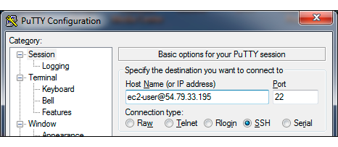Ensure that **Port** is 22

1. In the **Category** pane, expand **Connection**, expand **SSH**, and then select **Auth**. Complete the following:
   * Click **Browse**
   * Select the .ppk file that you generated for your key pair, and then click **Open**
   * Click **Open** to start the PuTTY session.

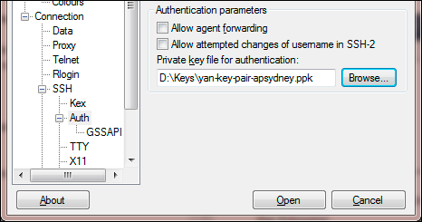

1. If this is the first time you have connected to this instance, PuTTY displays a security alert dialog box that asks whether you trust the host you are connecting to. Click **Yes**. A window opens and you are connected to your instance.

#### Connect from Mac or Linux using an SSH client

If you are using Mac or Linux computer to connect to your instance, your computer most likely includes and SSH client by default. You can check for an SSH client by typing **ssh** at the command line. If your computer doesn’t recognize the command, the OpenSSH project provides a free implementation of the full suite of SSH tools. For more information, see [http://www.openssh.org](http://www.openssh.org/).

Open your command shell and run the following command:

$ ssh -i */path/key_pair.pem* ec2-user@*public_ip*

For Amazon Linux, the default user name is ec2-user. For RHEL5, the user name is often root but might be ec2-user. For Ubuntu, the user name is ubuntu. For SUSE Linux, the user name is root. Otherwise, check with your AMI provider.

## Terminate Your Instance

The purpose of the tutorial in this chapter is to show you how to launch EC2 instance from AWS Management Console, so you can get basic understanding of EC2, key pair, and security groups. After you’ve finished with the instance that you created for this chapter, you should clean up, terminate the instance.

Terminating an instance effectively deletes it because you can’t reconnect to an instance after you’ve terminated it. This differs from stopping the instance; when you stop an instance, it is shut down and you are not billed for hourly usage or data transfer. Also, you can restart a stopped instance at any time.

#### To terminate the instance

1. Locate your instance in the list of instances on the **Instances** page. If you can’t find your instance, verify that you have selected the correct region.
2. Right-click the instance, select **Instance State** and then click **Terminate**.

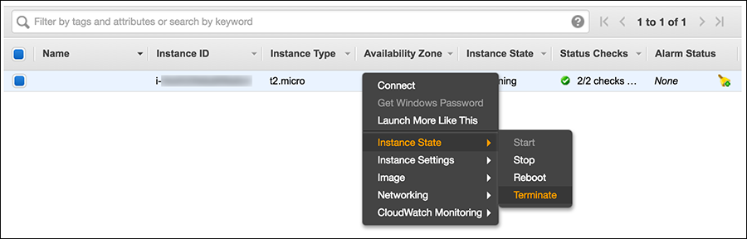

1. Click **Yes, Terminate** when prompted for confirmation.

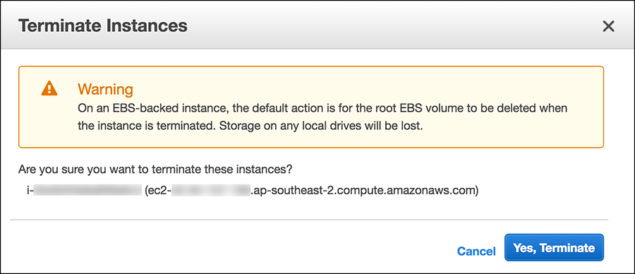

Most parts of this chapter is based on Amazon AWS Online Documentation. This chapter only covers the basics of AWS and EC2. If you want to learn more about EC2, see [Amazon EC2 User Guide](http://docs.aws.amazon.com/AWSEC2/latest/UserGuide/concepts.html)²⁴. For a complete list of Amazon AWS Documentation, visit [AWS Documentation](http://aws.amazon.com/documentation)²⁵. You can also watch Introduction to AWS videos here: [https://aws.](https://aws.amazon.com/training/intro_series/) [amazon.com/training/intro_series/](https://aws.amazon.com/training/intro_series/).

²⁴<http://docs.aws.amazon.com/AWSEC2/latest/UserGuide/concepts.html>

²⁵<http://aws.amazon.com/documentation>

# Chapter 2: Getting Started with Ansible

Ansible is a radically simple IT orchestration engine that automates configuration management, application deployment, and many other IT needs. Ansible models your IT infrastructure by looking at the comprehensive architecture of how all of your systems inter-relate, rather than just managing one system at a time. It uses no agents and no additional custom security infrastructure, so it’s easy to deploy — and most importantly, it uses a very simple language (YAML, in the form of Ansible playbooks) that allow you to describe your automation jobs in a way that approaches plain English.

Ansible works by connecting to your nodes and pushing out small programs, called “Ansible Modules” to them. These programs are written to be resource models of the desired state of the system. Ansible then executes these modules (over SSH by default), and removes them when finished. Your library of modules can reside on any machine, and there are no servers, daemons, or databases required.²⁶

YAML is a recursive acronym for “YAML Ain’t Markup Language”. YAML is a human- friendly data serialization standard for all programming languages. To learn more about YAML, visit [http://www.yaml.org](http://www.yaml.org/).

Unlike Chef and Puppet, Ansible uses an agentless architecture. You only need to install Ansible on the machines that you use to manage your infrastructure. Managed nodes are not required to install and run background daemons to connect with a controlling machine and pull configuration, thus reduces the overhead on the network.

In this chapter you’ll learn how to install Ansible, build an inventory file, use Ansible from the command line, write a simple playbook, and use Ansible modules.

## What You’ll Need

To follow the examples in this book, you’ll need a computer, preferably running Linux, connected to the Internet. You’ll also need to be able to run commands in a terminal and do simple editing of text files.

Throughout this book I will use the CentOS 6.5 (minimal install) distribution of Linux to run Ansible. Ansible runs on a number of different platforms, but I’m not going to provide detailed instructions for all of them. All EC2 instances provisioned by Ansible in this book’s examples will use the Amazon Linux AMI (Amazon Machine Images) which is based on Red Hat distribution, similar to CentOS.

²⁶<http://www.ansible.com/how-ansible-works>

## Installing Ansible

Ansible is written in Python. To install the latest version of Ansible, we will use **pip**. Pip is a tool used to manage packages of Python software and libraries. Ansible releases are pushed to pip as soon as they are released.

#### To install Ansible via pip:

1. Install **RHEL EPEL** repository. The EPEL (Extra Packages for Enterprise Linux) repository is a package repository for Red Hat Enterprise Linux (RHEL) or CentOS, maintained by people from Fedora Project community, to provide add-on packages from Fedora, which are not included in the commercially supported Red Hat product line.

$ sudo yum -y update

$ sudo yum -y install wget

$ wget <http://dl.fedoraproject.org/pub/epel/6/x86_64/epel-release-6-8.noarch.rpm>

$ sudo rpm -Uvh epel-release-6*.rpm

1. Install “Development tools” group. The “Development tools” are a yum group, which is a predefined bundle of software that can be installed at once, instead of having to install each application separately. The Development tools will allow you to build and compile software from source code. Tools for building RPMs are also included, as well as source code management tools like Git, SVN, and CVS.

$ sudo yum groupinstall -y 'development tools'

1. Install **python-pip** and **python-devel**

$ sudo yum -y install python-pip python-devel

1. Upgrade **setuptools**

$ sudo pip install setuptools --upgrade

1. Install **Ansible** via pip

$ sudo pip install ansible

After the installation has completed successfully, you will be able to run this command to show your Ansible’s version number:

$ ansible --version ansible 2.1.1.0

To upgrade ansible to the latest version available in pip repository:

$ sudo pip install ansible --upgrade

## SSH Keys

Ansible communicates with remote machines over SSH. By default, Ansible 1.3 and later will try to use native OpenSSH for remote communication when possible. It is recommended that you use SSH keys for SSH authentication, so Ansible won’t have to ask password to communicate with remote hosts.

#### To enable SSH keys authentication:

1. Create public and private keys using ssh-keygen

$ ssh-keygen

Generating public/private rsa key pair.

Enter file in which to save the key (/home/yan/.ssh/id_rsa):[press ENTER key] Enter passphrase (empty for no passphrase):[press ENTER key]

Enter same passphrase again:[press ENTER key]

Your identification has been saved in /home/yan/.ssh/id_rsa. Your public key has been saved in /home/yan/.ssh/id_rsa.pub. The key fingerprint is:

1. Copy the public key to remote host using ssh-copy-id

(For this example, I will use localhost as the “remote host”)

$ ssh-copy-id -i ∼/.ssh/id_rsa.pub localhost yan@localhost's password:[enter PASSWORD]

Now try logging into the machine, with "ssh 'localhost'", and check in:

.ssh/authorized_keys

to make sure we haven't added extra keys that you weren't expecting.

ssh-copy-id appends the keys to the remote-host’s .ssh/authorized_key.

1. Login to remote host without entering the password

$ ssh localhost

Last login: Sun Jul 31 10:17:35 2016 from ::1

$ exit logout

Connection to localhost closed.

## Inventory

Ansible works against multiple nodes in your infrastructure at the same time, by selecting portions of nodes listed in Ansible’s inventory file. By default, Ansible uses /etc/ansible/hosts for the inventory file. You can have another path for hosts file and specify the path using -i option when running ansible or ansible-playbook command.

The format for the host inventory file is an INI format and looks like this:

1 one.example.com

2

1. [webservers]
2. web1.example.com
3. web2.example.com
4. two.example.com

7

1. [dbservers]
2. db1.example.com
3. db2.example.com
4. two.example.com

The words in brackets are group names, which are used in classifying nodes and deciding what hosts you are controlling in an Ansible task. One node can be a member of more than one group, like two.example.com on the above example.

To add a lot of hosts with similar patterns you can specify range like this:

1. [webservers]
2. web[01:50].example.com

3

1. [databases]
2. db-[a:f].example.com

It is also possible to make groups of groups:

1. [sydney]
2. host1
3. host2

4

1. [singapore]
2. host3
3. host4

8

1. [asiapacific:children]
2. sydney
3. singapore

### Host Variables

You can specify variables in hosts file that will be used later in Ansible playbooks:

1. [webservers]
2. web1.example.com ansible_user=ec2-user
3. web2.example.com ansible_user=ubuntu

Assuming the inventory file path is /home/yan/ansible4aws/hosts, you can store host variables, in YAML format, in individual files:

/home/yan/ansible4aws/host_vars/web1.example.com

/home/yan/ansible4aws/host_vars/web2.example.com

For example, the data in the host variables file /home/yan/ansible4aws/host_vars/web1.example.com

might look like:

1. ---
2. ansible_user: ec2-user
3. ansible_port: 5300
4. ansible_ssh_private_key_file: /home/yan/.ssh/keypair1.pem

The following variables control how Ansible interacts with remote hosts:

**ansible_host**

The name of the host to connect to, if different from the alias you wish to give to it.

**ansible_port**

The ssh port number, if not 22

**ansible_user**

The default ssh user name to use.

**ansible_ssh_pass**

The ssh password to use (this is insecure, it’s strongly recommended to use –ask-pass or SSH keys)

**ansible_ssh_private_key_file**

Private key file used by ssh. Useful if using multiple keys and you don’t want to use SSH agent.

**ansible_ssh_common_args**

This setting is always appended to the default command line for **sftp**, **scp**, and **ssh**. Useful to configure a ProxyCommand for a certain host (or group).

**ansible_sftp_extra_args**

This setting is always appended to the default **sftp** command line.

**ansible_scp_extra_args**

This setting is always appended to the default **scp** command line.

**ansible_ssh_extra_args**

This setting is always appended to the default **ssh** command line.

**ansible_ssh_pipelining**

Determines whether or not to use SSH pipelining. This can override the pipelining setting in ansible.cfg.

Privilege escalation:

**ansible_become**

Equivalent to ansible_sudo or ansible_su, allows to force privilege escalation

**ansible_become_method**

Allows to set privilege escalation method

**ansible_become_user**

Equivalent to ansible_sudo_user or ansible_su_user, allows to set the user you become through privilege escalation

**ansible_become_pass**

Equivalent to ansible_sudo_pass or ansible_su_pass, allows you to set the privilege escalation password

Remote host environment parameters:

**ansible_shell_type**

The shell type of the target system. You should not use this setting unless you have set the ansible_shell_executable to a non-Bourne (sh) compatible shell. By default commands are formatted using sh-style syntax. Setting this to csh or fish will cause commands executed on target systems to follow those shell’s syntax instead.

**ansible_python_interpreter**

The target host python path. This is useful for systems with more than one Python or not located at “/usr/bin/python” such as *BSD, or where /usr/bin/python is not a 2.X series Python.

**ansible_*_interpreter**

Works for anything such as ruby or perl and works just like ansible_python_interpreter. This replaces shebang of modules which will run on that host.

You can find more documentation on host variables here: [http://docs.ansible.com/ansible/intro_](http://docs.ansible.com/ansible/intro_inventory.html#host-variables) [inventory.html#host-variables](http://docs.ansible.com/ansible/intro_inventory.html#host-variables)

### Group Variables

Variables can be applied to an entire group at once:

1. [sydney]
2. node1
3. node2

4

1. [sydney:vars]
2. ntp_server=ntp.sydney.example.com
3. proxy_server=proxy.sydney.example.com

It is also possible to assign variables to groups of groups:

1. [sydney]
2. host1
3. host2

4

1. [singapore]
2. host3
3. host4

8

1. [asiapacific:children]
2. sydney
3. singapore

12

1. [asiapacific:vars]
2. db_server=db1.asiapacific.example.com

Assuming the inventory file path is /home/yan/ansible4aws/hosts, you can store group variables, in YAML format, in individual files:

/home/yan/ansible4aws/group_vars/sydney

For example, the data in the group variables file /home/yan/ansible4aws/group_vars/sydney might look like:

1. ---
2. ntp_server: ntp.sydney.example.com
3. proxy_server: proxy.sydney.example.com

## Your First Commands

It’s time to get started with some Ansible basic commands. Let’s create our Ansible inventory file in your home directory /home/yan/ansible4aws/hosts. If the directory /home/yan/ansible4aws does not exist, create the directory first.

$ mkdir /home/yan/ansible4aws && cd /home/yan/ansible4aws

$ vi hosts

1. [local]
2. localhost

3

1. # You can add more hosts
2. # [mygroup]
3. # 192.168.1.10
4. # 192.168.1.11

Now ping all your nodes:

$ ansible -i hosts all -m ping

Ansible will attempt to connect to remote machines using your current user name, just like SSH would. To override the remote user name, use the -u parameter.

We can also run a live command on all of our nodes:

$ ansible -i hosts all -a "/bin/echo hello"

The above examples show how to use /usr/bin/ansible for running ad-hoc tasks. An ad-hoc command can be used to do quick things that you might not necessarily want to write a full playbook for. For example, if you want to restart some services on remote hosts.

## Playbooks

Playbooks are Ansible’s configuration, deployment, and orchestration language. They are a com- pletely different way to use Ansible than in ad-hoc task execution mode.

Playbooks are written in YAML format and have a minimum of syntax, which intentionally tries to not be a programming language or script, but rather a model of a configuration or a process. Writing in YAML format allow you to describe your automation jobs in a way that approaches plain English. It is easy to learn and easy to understand for new Ansible users, but it is also powerful for expert users.

Each playbook is composed of one or more ‘plays’ in a list. A play maps a group of hosts to some well defined roles, represented by ansible ‘tasks’. A task is a call to an Ansible module.

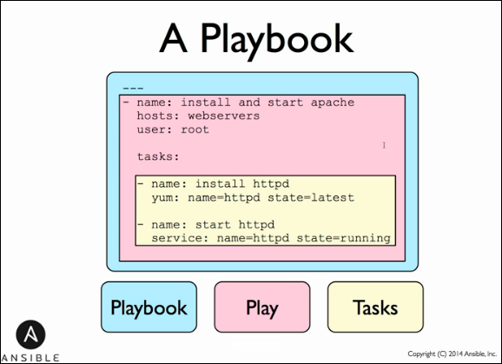

**Ansible Playbook**

A module can control system resources, like services, packages, or files, or anything on remote hosts. Modules can be executed from the command line using /usr/bin/ansible, or by writing a playbook and run it using /usr/bin/ansible-playbook command. Each module supports taking arguments. Nearly all modules take key=value arguments, space delimited. Some modules take no arguments, and the command/shell modules simply take the string of the command you want to run.

Examples of executing modules from the command line:

$ ansible webservers -m service -a "name=httpd state=started"

$ ansible webservers -m ping

$ ansible webservers -m command -a "/sbin/reboot -t now"

Executing modules from playbooks:

1. - name: reboot the servers
2. command: /sbin/reboot -t now

Ansible ships with hundreds of modules. Some examples of Ansible modules:

* + Package management: **yum, apt**
  + Remote execution: **command, shell**
  + Service management: **service**
  + File handling: **copy, template**
  + SCM: **git, subversion**
  + Database: **mysql_db, redis**
  + Cloud: **digital_ocean, ec2, gce**

For a complete list of Ansible modules, see [Ansible Module Index](http://docs.ansible.com/modules_by_category.html)²⁷ page.

Most modules are ‘idempotent’, they will only make changes in order to bring the system to the desired state. It is safe to rerun the same playbook multiple times. It won’t make changes if the desired state has been achieved.

## YAML Syntax

For Ansible playbook, nearly every YAML file starts with a list. Each item in the list is a list of key/value pairs, commonly called a “hash” or a “dictionary”. All YAML files should begin with "---", which indicates the start of a document.

All members of a list are lines beginning at the same indentation level starting with a “-“ (dash) character:

1. ---
2. - hosts: webservers
3. tasks:
4. - name: ensure apache is installed
5. yum: name=httpd state=present
6. - hosts: databases
7. tasks:
8. - name: ensure mysql server is installed
9. yum: name=mysql-server state=present

A play in playbook consists of three sections: the hosts section, the variables section, and the tasks section. You can include as many plays as you like in a single playbook.

²⁷<http://docs.ansible.com/modules_by_category.html>

### The hosts section

The hosts section defines hosts on which the play will be run, and how it will be run. In this section you can set the SSH username or other SSH-related settings needed to connect to the targeted hosts.

1. - hosts: webservers
2. remote_user: root

The hosts that a play will be run on must be set in the value of hosts. This value uses the same host-pattern-matching syntax as the one used in Ansible command line:

* + The following patterns target all hosts in inventory:

all

*

* + To address a specific host or set of hosts by name or IP addresses and wildcards:

one.example.com one.example.com:two.example.com 192.168.1.1

192.168.1.*

*.example.com

* + The following patterns address one or more groups. Groups separated by a colon indicate an “OR” configuration (the host may be in either one group or the other):

webservers webservers:dbservers

* + To exclude groups:

webservers:!sydney

all hosts must be in the webservers group but not in the sydney group

* + Group intersection:

webservers:&staging

all hosts must be in the webservers group and also in the staging group

* + You can also use regular expressions. Start the pattern with a "∼":

∼(web|db).*\.example\.com

In this section you can provide some parameters:

**become**

set to ‘true’/’yes’ to activate privilege escalation.

**become_user**

set to user with desired privileges, the user you ‘become’, NOT the user you login as. Does NOT imply *become: yes*, to allow it to be set at host level.

**become_method**

at play or task level overrides the default method set in ansible.cfg, set to ‘sudo’, ‘su’, ‘pbrun’, ‘pfexec, ‘doas’, or ‘dzdo’

**connection**

Tells Ansible what connection method to use to connect to the remote hosts. You can use ssh, paramiko, or local.

**gather_facts**

If set to no Ansible will not run the setup module to collect facts from remote hosts.

### The variables section

In this section you can define variables that apply to the entire play on all hosts. You can also tell Ansible to prompt for variables. This section allows you to have all the configuration for the play stored at the top, so you can easily read and modify.

1. - hosts: webservers
2. vars:
3. http_port: 80
4. region: ap-southeast-2

To use the variable in the tasks section, use "{{ variable }}" syntax:

1. - hosts: webservers
2. vars:
3. region: ap-southeast-2
4. tasks:
5. - name: create key pair
6. local_action:
7. module: ec2_key
8. region: "{{ region }}"

Variables can also be loaded from external YAML files. This is done using the vars_files directive:

1. - hosts: webservers
2. vars_files:
3. - /vars/external_vars.yml

You can instruct Ansible to prompt for variables using the vars_prompt directive:

1. vars_prompt:
2. - name: 'vpc_subnet_id'
3. prompt: 'Enter the VPC subnet ID: '

It is also possible to send variables over the Ansible command line:

Example:

1. ---

2

1. - hosts: '{{ hosts }}'
2. remote_user: '{{ user }}' 5
3. tasks:
4. - ...

Run the playbook and pass the variables:

$ ansible-playbook -i hosts site.yml --extra-vars "hosts=dbservers user=ec2-user"

### The tasks section

Each play contains a list of tasks. Tasks are executed in order, one at a time, against all hosts matched by the host pattern, before moving on to the next task. When running the playbook, which runs top to bottom, hosts with failed tasks are taken out of the execution for the entire playbook, and error messages for the hosts will be displayed. If the run failed, simply correct the playbook and rerun.

Every task should have a name. The name should have a good description of what the task do. It will be included in the output messages from running the playbook. Below the name line, you can declare the action. Tasks can be declared using the older “action:module options” format, but it is recommended to use the “module:options” format.

1. tasks:
2. - name: make sure apache is running
3. service: name=httpd state=running

The command and shell modules are the only modules that just take a list of arguments and don’t use the key=value form:

1. tasks:
2. - name: disable selinux
3. command: /sbin/setenforce 0

The command and shell modules will return error code. If the exit code is not zero you can ignore the error:

1. tasks:
2. - name: run somecommand and ignore the return code
3. shell: /usr/bin/somecommand
4. ignore_errors: yes

If the action line is getting too long, you can break it into separate lines, indent any continuation lines:

1. tasks:
2. - name: Copy somefile to remote host
3. copy: src=/home/somefile dest=/etc/somefile
4. owner=root group=root mode=0644

### Handlers

Handlers are lists of tasks, referenced by name, called by notify directive. Notify actions are triggered when the task made a change on the remote system. If many tasks in a play notify one handler, it will run only once, after all tasks completed in a particular play.

1. tasks:
2. - name: Configure ntp file
3. template: src=ntp.conf.j2 dest=/etc/ntp.conf
4. notify: restart ntp 5
5. handlers:
6. - name: restart ntp
7. service: name=ntpd state=restarted

The service ntpd will be restarted only if the template module made changes to remote hosts file

/etc/ntp.conf.

## Your First Playbook

Let’s create our first playbook and run it.

Make sure you have created the inventory file hosts:

$ cd /home/yan/ansible4aws

$ vi hosts

1. [local]
2. localhost

Create a playbook file site.yml:

$ vi site.yml

1. ---
2. - hosts: localhost
3. tasks:
4. - name: ensure apache is at the latest version
5. yum: name=httpd state=latest
6. - name: ensure apache is running
7. service: name=httpd state=started

Save the file and run the playbook:

$ ansible-playbook -i hosts site.yml

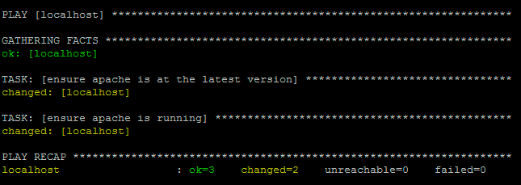

**Running Our First Playbook**

Apache is now installed and running.

# ps ax | grep httpd

2357 ? Ss 0:00 /usr/sbin/httpd

2360 ? S 0:00 /usr/sbin/httpd

2361 ? S 0:00 /usr/sbin/httpd

2362 ? S 0:00 /usr/sbin/httpd

2363 ? S 0:00 /usr/sbin/httpd

2364 ? S 0:00 /usr/sbin/httpd

2365 ? S 0:00 /usr/sbin/httpd

$ yum info httpd

Installed Packages Name : httpd

Arch : x86_64 Version : 2.2.15

Release : 30.el6.centos Size : 2.9 M

Repo : installed From repo : updates

Summary : Apache HTTP Server URL : <http://httpd.apache.org/> License : ASL 2.0

Now, let’s uninstall Apache using our playbook

$ vi site.yml

1. ---
2. - hosts: localhost
3. tasks:
4. - name: ensure apache is absent
5. yum: name=httpd state=absent

Save the file and run the playbook:

$ ansible-playbook -i hosts site.yml

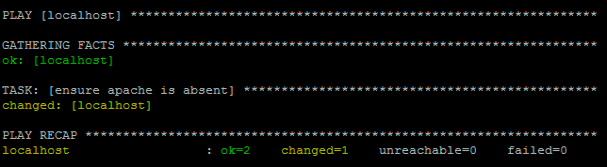

**Ensure Apache is Absent**

Apache is successfully uninstalled from localhost.

## Roles and Include Statements

It is possible to write everything in a single playbook, list all tasks in one very large file for your entire infrastructure, but it will be very hard to read and to maintain. Roles and include statements can help you organize things.

At a basic level, include directive can be used to break up bits of configuration policy into smaller files. You can write tasks in a separate file and include it in your play. Playbooks can also include plays from other playbook files.

A task include file simply contains a flat list of tasks, for example:

1. ---
2. # saved as tasks/task1.yml 3
3. - name: task one
4. command: /bin/commandone

6

1. - name: task two
2. command: /bin/commandtwo

Include directives look like this, and can be mixed in with regular tasks in a playbook:

1. tasks:
2. - include: tasks/task1.yml

Roles are a better way to organize your playbooks. Roles are ways of automatically loading certain variables, tasks, and handlers based on a known file structure. Grouping content using roles makes it easier to share roles with other users.

Example project structure:

site.yml webservers.yml dbservers.yml roles/

common/ files/ templates/ tasks/ handlers/ vars/ meta/

webservers/ files/ templates/ tasks/ handlers/ vars/ meta/

In a playbook, it would look like this:

1. ---
2. - hosts: webservers
3. roles:
4. - common
5. - webservers

This designates the following behaviors, for each role ‘x’:

* + If roles/x/tasks/main.yml exists, tasks listed therein will be added to the play
  + If roles/x/handlers/main.yml exists, handlers listed therein will be added to the play
  + If roles/x/vars/main.yml exists, variables listed therein will be added to the play
  + If roles/x/meta/main.yml exists, any role dependencies listed therein will be added to the list of roles
  + Any copy tasks can reference files in roles/x/files/ without having to path them relatively or absolutely
  + Any script tasks can reference scripts in roles/x/files/ without having to path them relatively or absolutely
  + Any template tasks can reference files in roles/x/templates/ without having to path them relatively or absolutely
  + Any include tasks can reference files in roles/x/tasks/ without having to path them relatively or absolutely

Ansible is a young rising project and may be rapidly changing. To update your knowledge of Ansible, visit [Ansible documentations](http://docs.ansible.com/)²⁸ page.

Ansible provides a nice quick start video. You can find it here [http://www.ansible.com/](http://www.ansible.com/resources) [resources](http://www.ansible.com/resources)

²⁸[http://docs.ansible.com](http://docs.ansible.com/)

# Chapter 6: VPC Provisioning with Ansible

Amazon Virtual Private Cloud (Amazon VPC) enables you to launch Amazon Web Services (AWS) resources into a virtual network that you’ve defined. This virtual network closely resembles a traditional network that you’d operate in your own data center, with the benefits of using the scalable infrastructure of AWS. ²⁹

Using Ansible for Amazon VPC provisioning allows you to manage your AWS infrastructure as a code base. It means that you are writing code to define your infrastructure. By applying version control system (VCS) like git, your infrastructure is subject to version control. You will be able to easily re-create your whole infrastructure, revert back to previous version of your infrastructure, and setup a consistent development, testing, and production environment.

In this chapter, you will learn about AWS Virtual Private Cloud (VPC) basics and how to use Ansible to provision AWS VPC; including VPC subnets, VPC routing tables, and VPC security groups. You will learn how to use Ansible to launch EC2 instances in VPC subnet and attach VPC security groups to the instances. I will also show you how to provision NAT instance in your VPC.

## The Default VPC

When you launch an EC2 instance without creating and specifying a non-default VPC, Amazon launches the instance into your default VPC. All examples from chapter 1, 3, and 4 launched EC2 instances into the default VPC. You can see the default VPC on your Amazon VPC console [https:](https://console.aws.amazon.com/vpc)

[//console.aws.amazon.com/vpc](https://console.aws.amazon.com/vpc).

Amazon creates a default VPC with the following set up:

* + a default subnet in each Availability Zone
  + an Internet gateway connected to your default VPC
  + a main route table for your default VPC with a rule that sends all traffic destined for the Internet to the Internet gateway
  + a default security group associated with your default VPC
  + a default network access control list (ACL) associated with your VPC
  + a default DHCP options set for your AWS account associated with your default VPC

²⁹<http://docs.aws.amazon.com/AmazonVPC/latest/UserGuide/VPC_Introduction.html>

Amazon has multiple locations world-wide. These locations are composed of regions and Availability Zones. Each *region* is a separate geographic area. Each region has multiple, isolated locations known as *Availability Zones*. Amazon provides you the ability to place resources, such as instances, and data in multiple locations. Resources aren’t replicated across regions unless you do so specifically.

A *network access control list (ACL)* is an optional layer of security that acts as a firewall for controlling traffic in and out of a subnet. You might set up network ACLs with rules similar to your security groups in order to add an additional layer of security to your VPC.

The following figure illustrates the key components that Amazon set up for a default VPC: ³⁰

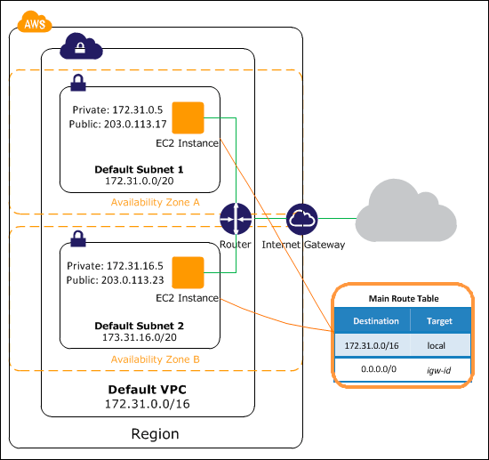

The CIDR block for a default VPC is always 172.31.0.0/16, which provides up to 65,536 private IP addresses. A default subnet has a /20 subnet mask, which provides up to 4,096 addresses per subnet. Some addresses are reserved for Amazon’s use.

By default, a default subnet is connected to the Internet through the Internet gateway. Instances that you launch into a default subnet receive both a private IP address and a public IP address.

³⁰<http://docs.aws.amazon.com/AmazonVPC/latest/UserGuide/default-vpc.html>

## Getting Started with VPC

A virtual private cloud (VPC) is a virtual network dedicated to your AWS account. It is logically isolated from other virtual networks in the AWS cloud. You can launch your AWS resources, such as Amazon EC2 instances, into your VPC. ³¹

When you create a VPC, you specify the range of IP addresses for the VPC in the form of a Classless Inter-Domain Routing (CIDR) block; for example, 10.0.0.0/16. For more information about CIDR notation and what “/16” means, go to [https://en.wikipedia.org/wiki/Classless_Inter-](https://en.wikipedia.org/wiki/Classless_Inter-Domain_Routing) [Domain_Routing](https://en.wikipedia.org/wiki/Classless_Inter-Domain_Routing).

You must use a private address space for the VPC CIDR block. For more information about private address, go to <https://en.wikipedia.org/wiki/Private_network>.

You can create a VPC that spans multiple Availability Zones. After creating a VPC, you can add one or more subnets in each Availability Zone. When you create a subnet, you specify the CIDR block for the subnet, which is a subset of the VPC CIDR block. Each subnet must reside entirely within one Availability Zone and cannot span zones. Availability Zones are distinct locations that are engineered to be isolated from failures in other Availability Zones. By launching instances in separate Availability Zones, you can protect your applications from the failure of a single location.

For more information about VPC and subnet sizing go to [http://docs.aws.amazon.com/AmazonVPC/](http://docs.aws.amazon.com/AmazonVPC/latest/UserGuide/VPC_Subnets.html) [latest/UserGuide/VPC_Subnets.html](http://docs.aws.amazon.com/AmazonVPC/latest/UserGuide/VPC_Subnets.html).

There are many tools available to help you calculate subnet CIDR blocks; for example, see [http:](http://www.subnet-calculator.com/cidr.php)

[//www.subnet-calculator.com/cidr.php](http://www.subnet-calculator.com/cidr.php).

To get started with Amazon VPC, let’s create a VPC and subnets from the VPC console. If you have done this before, you can skip this section. We will create a VPC for a multi-tier website scenario, with the web servers in a public subnet and the database servers in a private subnet. This scenario will be used for all examples in this chapter.

The instances in the public subnet can receive inbound traffic directly from the Internet, whereas the instances in the private subnet can’t. The instances in the public subnet can send outbound traffic directly to the Internet, whereas the instances in the private subnet can’t. Instead, the instances in the private subnet can access the Internet by using a network address translation (NAT) instance that you launch into the public subnet. AWS also provides managed NAT gateway service you can launch in your VPC, but for this book I will not use that. For your production environment you will definitely need to use AWS managed NAT service to provide better availability and higher bandwidth.

The following diagram shows the key components of the configuration for the scenario. ³²

³¹<http://docs.aws.amazon.com/AmazonVPC/latest/UserGuide/VPC_Subnets.html>

³²<http://docs.aws.amazon.com/AmazonVPC/latest/UserGuide/VPC_Scenario2.html>

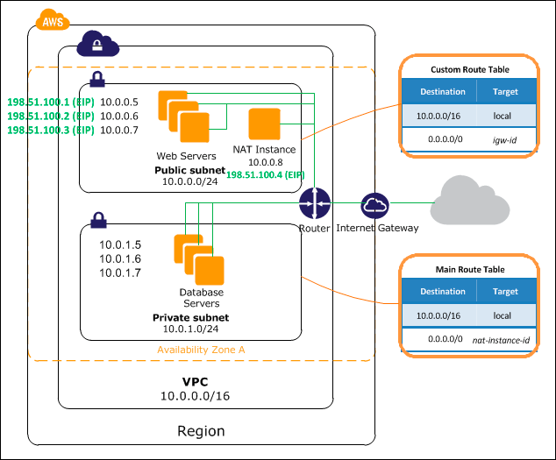

### VPC Sizing

**VPC Diagram**

The allowed CIDR block size for a VPC is between a /28 netmask and /16 netmask, therefore the VPC can contain from 16 to 65,536 IP addresses.

You can’t change the size of a VPC after you create it. If your VPC is too small to meet your needs, you must terminate all the instances in the VPC, delete the VPC, and then create a new, larger VPC.

The following list describes the basic components presented in the configuration diagram for this scenario:

* A virtual private cloud (VPC) of size /16 (CIDR: 10.0.0.0/16). This provides 65,536 private IP addresses.
* A public subnet of size /24 (CIDR: 10.0.0.0/24). This provides 256 private IP addresses.
* A private subnet of size /24 (CIDR: 10.0.1.0/24). This provides 256 private IP addresses.
* An Internet gateway. This connects the VPC to the Internet and to other AWS products, such as Amazon Simple Storage Service (Amazon S3).
* Instances with private IP addresses in the subnet range (examples: 10.0.0.5, 10.0.1.5), which enables them to communicate with each other and other instances in the VPC. Instances in the public subnet also have Elastic IP addresses (example: 198.51.100.1), which enable them to be reached from the Internet. Instances in the private subnet are back-end servers that don’t need to accept incoming traffic from the Internet; however, they can send requests to the Internet using the NAT instance (see the next bullet).
* A network address translation (NAT) instance with its own Elastic IP address. This enables instances in the private subnet to send requests to the Internet (for example, for software updates).
* A custom route table associated with the public subnet. This route table contains an entry that enables instances in the subnet to communicate with other instances in the VPC, and an entry that enables instances in the subnet to communicate directly with the Internet.
* The main route table associated with the private subnet. The route table contains an entry that enables instances in the subnet to communicate with other instances in the VPC, and an entry that enables instances in the subnet to communicate with the Internet through the NAT instance.

#### To create a VPC:

1. Open the Amazon VPC console at <https://console.aws.amazon.com/vpc/>.
2. In the navigation pane, click **Your VPCs**.

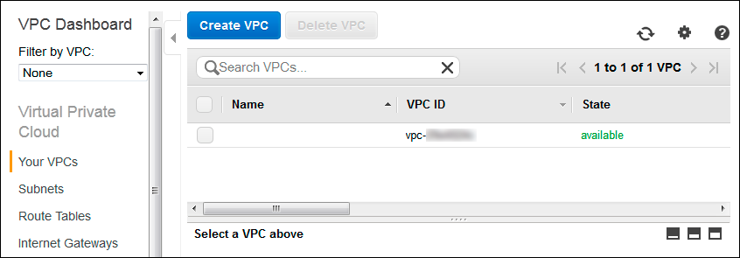

1. Click **Create VPC**.
2. Enter the desired **Name tag** and **CIDR block** for the VPC and select **Tenancy: Default**.

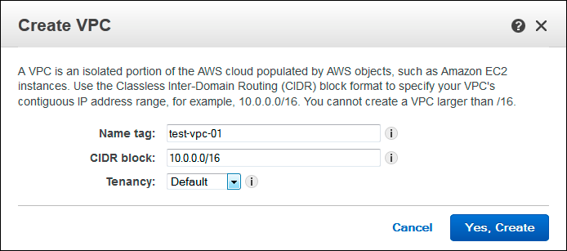

1. Click **Yes, Create** button.

Each VPC has a related instance tenancy attribute. You can’t change the instance tenancy of a VPC after you create it. A dedicated VPC tenancy attribute means that all instances launched into the VPC are Dedicated Instances, regardless of the value of the tenancy attribute for the instance. If you set this to default, then the tenancy attribute will follow the tenancy attribute setting on each instance. A default tenancy instance runs on shared hardware. A dedicated tenancy instance runs on single-tenant hardware.

*Dedicated Instances* are Amazon EC2 instances that run in a virtual private cloud (VPC) on hardware that’s dedicated to a single customer. Your Dedicated Instances are physically isolated at the host hardware level from your instances that aren’t Dedicated Instances and from instances that belong to other AWS accounts. To see the pricing for dedicated instances go to <http://aws.amazon.com/ec2/purchasing-options/dedicated-instances/>.

#### To create an Internet gateway and attach it to a VPC:

1. In the VPC Dashboard navigation pane, click **Internet Gateways**.

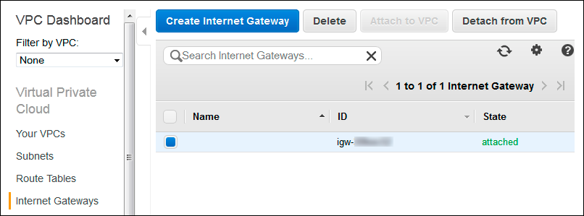

1. Click **Create Internet Gateway**.
2. Enter the desired **Name tag** for this Internet gateway.

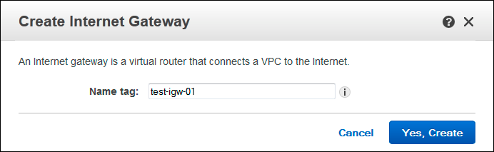

1. Click **Yes, Create** button.
2. Select the new Internet gateway and click **Attach to VPC**

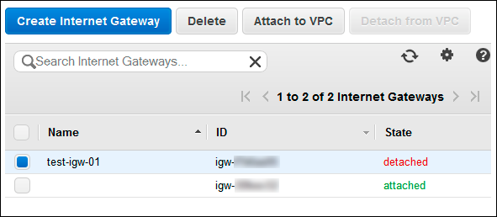

1. Select the desired VPC and click **Yes, Attach**.

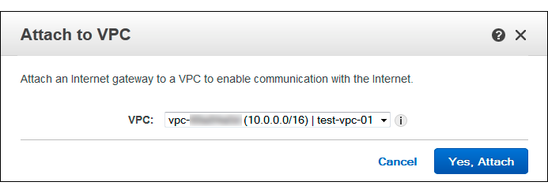

#### To create subnets on the VPC:

1. In the VPC Dashboard navigation pane, click **Subnets**.

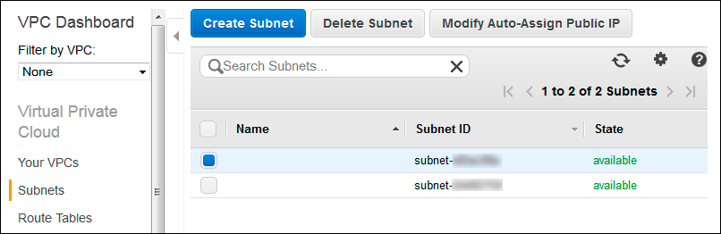

1. Click **Create Subnet**
2. Enter the desired **Name tag** and **CIDR block** for the public subnet, select VPC and Availability Zone.

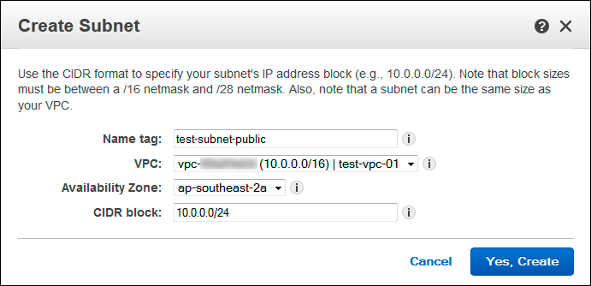

1. Click **Yes, Create**.
2. Click **Create Subnet**.

Enter the desired **Name tag** and **CIDR block** for the private subnet, select VPC and Availability Zone.

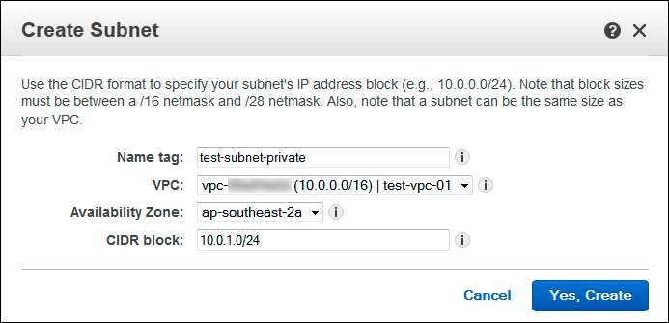

1. Click **Yes, Create**.

### Route Tables

The following are the basic things that you need to know about route tables:³³

* + Your VPC has an implicit router.
  + Your VPC automatically comes with a main route table that you can modify.
  + You can create additional custom route tables for your VPC.
  + Each subnet must be associated with a route table, which controls the routing for the subnet. If you don’t explicitly associate a subnet with a particular route table, the subnet uses the main route table.
  + You can replace the main route table with a custom table that you’ve created (so that this table is the default table each new subnet is associated with).
  + Each route in a table specifies a destination CIDR and a target.

### Main Route Table

When you create a VPC, it automatically has a main route table. To see the main route tables for your VPC, in the VPC Dashboard navigation pane, click **Route Tables**.

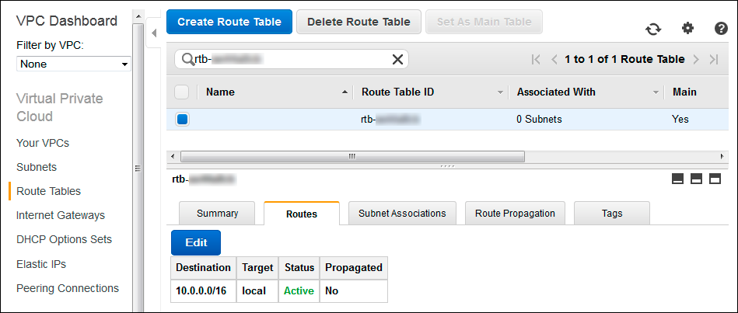

**The Main Route Table**

Initially, the main route table (and every route table in a VPC) contains only a single route: a local route that enables communication within the VPC. You can’t modify the local route in a route table. Whenever you launch an instance in the VPC, the local route automatically covers that instance; you don’t need to add the new instance to a route table.

³³<http://docs.aws.amazon.com/AmazonVPC/latest/UserGuide/VPC_Route_Tables.html>

If you don’t explicitly associate a subnet with a route table, the subnet is implicitly associated with the main route table. However, you can still explicitly associate a subnet with the main route table. You might do that if you change which table is the main route table. The console shows the number of subnets associated with each table. Only explicit associations are included in that number.

For the scenario in this section, the main route tables should contain an entry that enables instances in the private subnet to communicate with the Internet through the NAT instance, but I’m not going to provide instructions for manually creating a NAT instance here. If you want to learn about this, follow the instruction here: [http://docs.aws.amazon.com/AmazonVPC/latest/UserGuide/VPC_](http://docs.aws.amazon.com/AmazonVPC/latest/UserGuide/VPC_NAT_Instance.html) [NAT_Instance.html](http://docs.aws.amazon.com/AmazonVPC/latest/UserGuide/VPC_NAT_Instance.html) and then you could edit the main route table and add an entry: destination 0.0.0.0/0, target *nat-instance-id*. I will show you later in this chapter how to provision a NAT instance using Ansible.

### Custom Route Tables

#### To create a custom route table for the public VPC:

1. In the VPC Dashboard navigation pane, click **Route Tables**.
2. Click **Create Route Table**.
3. Enter the desired **Name tag** and select **VPC**.

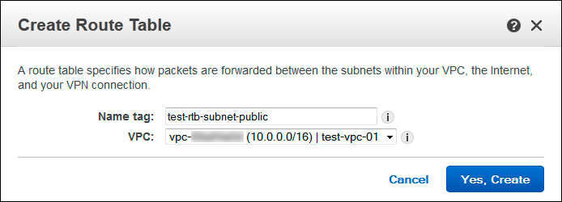

1. Click **Yes, Create**.

#### To edit the custom route table and associate it to the public subnet:

1. In the VPC Dashboard navigation pane, click **Route Tables**. Select the custom route table we created for public subnet and select the **Routes** tab.

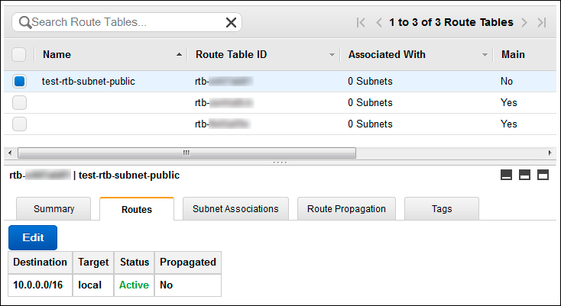

1. Click **Edit** button.
2. Enter 0.0.0.0/0 CIDR block in the **Destination** field and select the Internet gateway from the **Target** list.

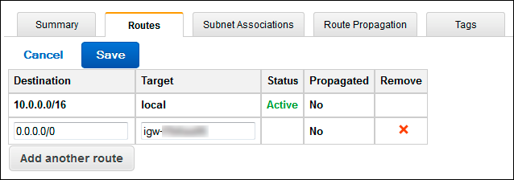

1. Click **Save**.
2. Select **Subnet Associations** tab.

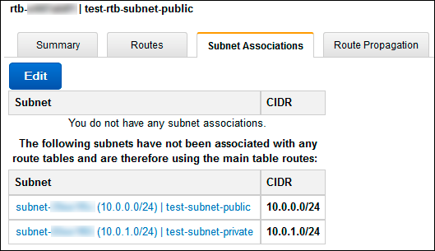

1. Click **Edit**.
2. Select the **Associate** check box for public subnet and click **Save**.

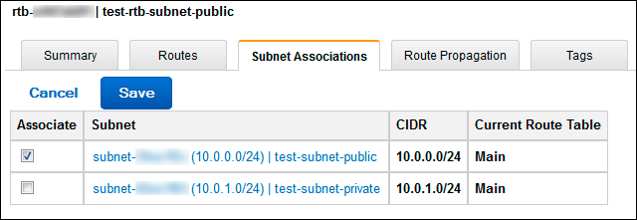

## VPC Provisioning

We will use Ansible ec2_vpc module to create or terminate AWS Virtual Private Cloud (VPC). Options for this module are listed in the following table:

|  |  |  |  |  |
| --- | --- | --- | --- | --- |
| **parameter** | **required** | **default** | **choices** | **comments** |
| aws_access_key | no |  |  | AWS access key. If not set then the value of the AWS_ACCESS_KEY environment variable is used aliases: ec2_access_key, access_key |
| aws_secret_key | no |  |  | AWS secret key. If not set then the value of the AWS_SECRET_KEY environment variable is used aliases: ec2_secret_key, secret_key |
| cidr_block | yes |  |  | The cidr block representing the VPC,  e.g. 10.0.0.0/16, required when state is ‘present’ |
| dns_hostnames | no | yes | yes no | Toggles the “Enable DNS hostname support for instances” flag |
| dns_support | no | yes | yes no | Toggles the “Enable DNS resolution” flag |
| ec2_url | no |  |  | URL to use to connect to EC2 or your Eucalyptus cloud (by default the module will use EC2 endpoints). Must be specified if region is not used. If not set then the value of the EC2_URL environment variable, if any, is used |
| instance_tenancy | no | default | default dedicated | The supported tenancy options for instances launched into the VPC |
| internet_gateway | no | no | yes no | Toggles whether there should be an Internet gateway attached to the VPC |
| profile  (added in 1.6) | no |  |  | Uses a boto profile. Only works with boto >= 2.24.0 |
| region | no |  |  | Region in which the resource exists |
| resource_tags | yes |  |  | A dictionary array of resource tags of the form:  { tag1: value1, tag2: value2 }. Tags in this list are used in conjunction with CIDR block to uniquely identify a VPC in lieu of vpc_id.  Therefore, if CIDR/Tag combination does not exist, a new VPC will be created. VPC tags not on this list will be ignored. |
| route_tables | no |  |  | A dictionary array of route tables to add of the form: { subnets: [172.22.2.0/24, routes: |

**parameter required default choices comments**

[{ dest: 0.0.0.0/0, gw: igw},] }. Where the

subnets list is those subnets the route table

should be associated with, and the routes list is a list of routes to be in the table. The special keyword for the gw of igw specifies that the route should go through the internet gateway attached to the VPC. gw also accepts

instance-ids. This module is currently unable to affect the “main” route table due to some limitations in boto, so you must explicitly define the associated subnets or they will be attached to the main table implicitly.

security_token no AWS STS security token. If not set then the

(added in 1.6) value of the AWS_SECURITY_TOKEN or EC2_SECURITY_TOKEN environment variable is used.

aliases: access_token

state yes present Create or terminate the VPC

subnets no A dictionary array of subnets to add of the form

{ cidr: ..., az: ... , resource_tags: ...

}. .

Where az is the desired availability zone of the

subnet, but it is not required.

All VPC subnets not in this list will be removed

validate_certs no yes yes When set to “no”, SSL certificates will not be

no validated for boto versions >= 2.6.0. (added in Ansible 1.5)

vpc_id no A VPC id to terminate when state=absent

wait no no yes Wait for the VPC to be in state ‘available’

no before returning

wait_timeout no 300 How long before wait gives up, in seconds

The following playbook will show you how to create VPC, subnets, and route tables, using the same public and private subnets scenario as used in preceding section.

$ cd /home/yan/ansible4aws

$ vi vpc_create.yml

1. ---
2. - hosts: localhost
3. connection: local
4. gather_facts: no
5. vars:
6. region: ap-southeast-2
7. # prefix for naming
8. prefix: staging
9. # availability zone
10. az: ap-southeast-2a
11. tasks:
12. - name: create vpc
13. ec2_vpc:
14. region: "{{ region }}"
15. cidr_block: 10.0.0.0/16
16. resource_tags: '{"Name":"{{ prefix }}_vpc"}'
17. subnets:

18 - cidr: 10.0.0.0/24

1. az: "{{ az }}"
2. resource_tags: '{"Name":"{{ prefix }}_subnet_public"}'

21 - cidr: 10.0.1.0/24

1. az: "{{ az }}"
2. resource_tags: '{"Name":"{{ prefix }}_subnet_private"}'
3. internet_gateway: yes
4. route_tables:
5. - subnets:

27 - 10.0.0.0/24

28 routes:

29 - dest: 0.0.0.0/0

1. gw: igw
2. register: vpc
3. - name: write vpc id to {{ prefix }}_vpc_info file
4. shell: echo "{{ prefix }}"_vpc":" "{{ vpc.vpc_id }}"
5. > "{{ prefix }}"_vpc_info
6. - name: write subnets id to {{ prefix }}_vpc_info file
7. shell: echo "{{ item.resource_tags.Name }}"":" "{{ item.id }}"
8. >> "{{ prefix }}"_vpc_info
9. with_items: vpc.subnets

Run the playbook:

$ ansible-playbook -i hosts vpc_create.yml

The playbook will create a VPC with resource tags Name=staging_vpc and 2 subnets with resource

tags Name=staging_subnet_public and Name=staging_subnet_private. You could easily create a duplicate VPC with its subnets, route tables, etc simply by changing the prefix variable and run the playbook again.

You should see the staging_vpc created and listed on the VPC console. Open the Amazon VPC console at <https://console.aws.amazon.com/vpc/> and select **Your VPCs** in the navigation pane.

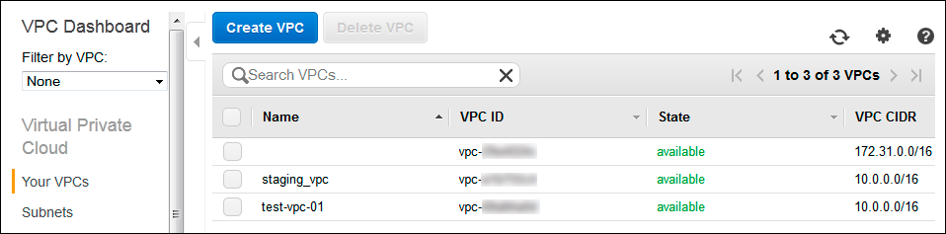

**staging_vpc**

You should also see new staging subnets on the **Subnets** list:

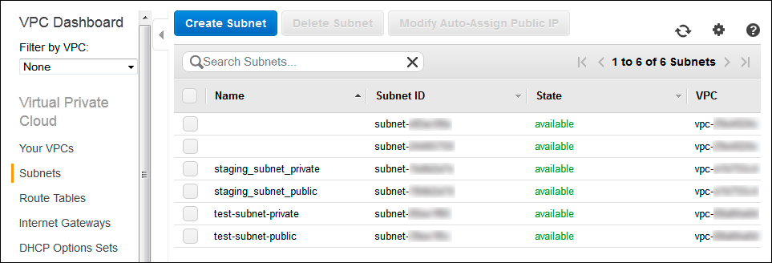

**New Subnets**

You can see from the preceding playbook that I registered the output of ec2_vpc module then wrote the VPC id and subnets id to a file called staging_vpc_info.

The content of staging_vpc_info file should look like this:

* 1. staging_vpc: vpc-xxxxxxxx
  2. staging_subnet_public: subnet-xxxxxxxx
  3. staging_subnet_private: subnet-xxxxxxxx

We can use the staging_vpc_info file as a variables file for another playbook.

For example, the following is a playbook to delete the VPC we have created with the preceding playbook.

$ vi vpc_delete.yml

1. ---
2. - hosts: localhost
3. connection: local
4. gather_facts: no
5. vars:
6. region: ap-southeast-2
7. vars_files:
8. - staging_vpc_info
9. tasks:
10. - name: delete vpc
11. ec2_vpc:
12. region: "{{ region }}"
13. state: absent
14. # get the vpc_id from staging_vpc_info file
15. vpc_id: "{{ staging_vpc }}"
16. wait: yes

You could run the vpc_delete.yml playbook to delete the staging_vpc you have created with the vpc_create.yml playbook. Simply re-run the vpc_create.yml playbook to create new staging_vpc after the deletion.

When you delete a VPC, Amazon deletes all its components, such as subnets, security groups, network ACLs, route tables, Internet gateways, VPC peering connections, and DHCP options. If you have instances launched in the VPC, you have to terminate all instances in the VPC first before deleting the VPC.

## VPC Security Groups

We have learned about Security Groups provisioning in Chapter 3. A *security group* acts as a virtual firewall for your instance to control inbound and outbound traffic. When you launch an instance in a VPC, you can assign the instance to up to five security groups. Security groups act at the instance level, not the subnet level. Therefore, each instance in a subnet in your VPC could be assigned to a different set of security groups. If you don’t specify a particular group at launch time, the instance is automatically assigned to the default security group for the VPC. ³⁴

The following are the basic characteristics of security groups for your VPC:

* + You can create up to 100 security groups per VPC. You can add up to 50 rules to each security group. If you need to apply more than 50 rules to an instance, you can associate up to 5 security groups with each network interface.
  + You can specify allow rules, but not deny rules.
  + You can specify separate rules for inbound and outbound traffic.
  + By default, no inbound traffic is allowed until you add inbound rules to the security group.
  + By default, all outbound traffic is allowed until you add outbound rules to the group (and then, you specify the outbound traffic that’s allowed).
  + Responses to allowed inbound traffic are allowed to flow outbound regardless of outbound rules, and vice versa (security groups are therefore stateful).
  + Instances associated with a security group can’t talk to each other unless you add rules allowing it (exception: the default security group has these rules by default).
  + After you launch an instance, you can change which security groups the instance is associated with.

To create, modify, or delete security groups in a VPC, we’ll use the **ec2_group** module like the one we used in Chapter 3. To see the options for this module, please refer to the table in Chapter 3 - Security Groups section. We need to add the vpc_id option to specify in which VPC we want to create/modify/delete the security group.

We will create security groups for web servers in public subnet, database servers in private subnet, and NAT instance in public subnet:

* + Webservers security group will allow the web servers to receive Internet traffic (TCP port 80 and 443), SSH (TCP port 22) from your computer’s or network’s public IP address, and allow MySQL database access (TCP port 3306) to database servers group.
  + Database security group will allow the web servers group to access MySQL database, and allow outbound HTTP and HTTPS access to the Internet.

³⁴<http://docs.aws.amazon.com/AmazonVPC/latest/UserGuide/VPC_SecurityGroups.html>

* + NAT security group will allow the NAT instance to receive inbound HTTP and HTTPS traffic from private subnet, allow SSH from your computer’s or network’s public IP address, and allow outbound HTTP and HTTPS access to the Internet.

First, we will create a playbook to provision the security groups with empty rules. This playbook will be useful to remove dependencies from the security groups. Later on, if you want to delete the security groups run this playbook first to empty the rules, so the deletion won’t produce dependency error.

$ cd /home/yan/ansible4aws

$ vi sg_empty.yml

1. ---
2. - hosts: localhost
3. connection: local
4. gather_facts: no
5. vars_files:
6. - staging_vpc_info
7. vars:
8. #your region
9. region: ap-southeast-2
10. #prefix for naming
11. prefix: staging
12. vpc_id: "{{ staging_vpc }}"
13. tasks:
14. - name: create empty security group for webservers
15. ec2_group:
16. region: "{{ region }}"
17. vpc_id: "{{ vpc_id }}"
18. name: "{{ prefix }}_sg_web"
19. description: security group for webservers
20. - name: create empty security group for databases
21. ec2_group:
22. region: "{{ region }}"
23. vpc_id: "{{ vpc_id }}"
24. name: "{{ prefix }}_sg_database"
25. description: security group for databases
26. - name: create empty security group for nat
27. ec2_group:
28. region: "{{ region }}"
29. vpc_id: "{{ vpc_id }}"
30. name: "{{ prefix }}_sg_nat"
31. description: security group for nat

Run the playbook:

$ ansible-playbook -i hosts sg_empty.yml

The following security groups should be created in your VPC with empty rules: staging_sg_web, staging_sg_database, and staging_sg_nat. You can see the security groups on your VPC console <https://console.aws.amazon.com/vpc/>, select **Security Groups** in the navigation pane.

We will modify the rules using another playbook:

$ vi sg_modify.yml

* 1. ---
  2. - hosts: localhost
  3. connection: local
  4. gather_facts: no
  5. vars_files:
  6. - staging_vpc_info
  7. vars:
  8. #your region
  9. region: ap-southeast-2
  10. #your ip address
  11. allowed_ip: 123.xxx.xxx.xxx/32
  12. #prefix for naming
  13. prefix: staging
  14. vpc_id: "{{ staging_vpc }}"
  15. private_subnet: 10.0.1.0/24
  16. tasks:
  17. - name: modify sg_web rules
  18. ec2_group:
  19. region: "{{ region }}"
  20. vpc_id: "{{ vpc_id }}"
  21. #your security group name
  22. name: "{{ prefix }}_sg_web"
  23. description: security group for webservers
  24. rules:
  25. # allow ssh access from your ip address
  26. - proto: tcp
  27. from_port: 22
  28. to_port: 22
  29. cidr_ip: "{{ allowed_ip }}"
  30. # allow http access from anywhere
  31. - proto: tcp
  32. from_port: 80
  33. to_port: 80

|  |  |  |
| --- | --- | --- |
| 34 |  | cidr_ip: 0.0.0.0/0 |
| 35 | # | allow https access from anywhere |
| 36 | - | proto: tcp |
| 37 |  | from_port: 443 |
| 38 |  | to_port: 443 |
| 39 |  | cidr_ip: 0.0.0.0/0 |

1. rules_egress:
2. - proto: tcp
3. from_port: 3306
4. to_port: 3306
5. group_name: "{{ prefix }}_sg_database"
6. - name: modify sg_database rules
7. ec2_group:
8. region: "{{ region }}"
9. vpc_id: "{{ vpc_id }}"
10. name: "{{ prefix }}_sg_database"
11. description: security group for databases
12. rules:
13. - proto: tcp
14. from_port: 3306
15. to_port: 3306
16. group_name: "{{ prefix }}_sg_web"
17. rules_egress:
18. - proto: tcp
19. from_port: 80
20. to_port: 80
21. cidr_ip: 0.0.0.0/0
22. - proto: tcp
23. from_port: 443
24. to_port: 443
25. cidr_ip: 0.0.0.0/0
26. - name: modify sg_nat rules
27. ec2_group:
28. region: "{{ region }}"
29. vpc_id: "{{ vpc_id }}"
30. name: "{{ prefix }}_sg_nat"
31. description: security group for nat
32. rules:
33. # allow ssh access from your ip address
34. - proto: tcp
35. from_port: 22
36. to_port: 22

|  |  |  |
| --- | --- | --- |
| 76 |  | cidr_ip: "{{ allowed_ip }}" |
| 77 | # | allow http access from private subnet |
| 78 | - | proto: tcp |
| 79 |  | from_port: 80 |
| 80 |  | to_port: 80 |
| 81 |  | cidr_ip: "{{ private_subnet }}" |
| 82 | # | allow https access from private subnet |
| 83 | - | proto: tcp |
| 84 |  | from_port: 443 |
| 85 |  | to_port: 443 |
| 86 |  | cidr_ip: "{{ private_subnet }}" |

1. rules_egress:
2. - proto: tcp
3. from_port: 80
4. to_port: 80
5. cidr_ip: 0.0.0.0/0
6. - proto: tcp
7. from_port: 443
8. to_port: 443
9. cidr_ip: 0.0.0.0/0

Run the playbook and you can see the rules changed.

Now from the VPC console, try to delete staging_sg_web. Right click on the security group and select **Delete Security Group**, click **Yes, Delete**. It will tell you that you could not delete the security group because it has a dependent object, which is staging_sg_database in its outbound rules.

You could run the sg_empty.yml playbook to remove all rules from the security groups, then you could delete the security group without dependency issue.

You can use the following playbook to delete the security groups:

$ vi sg_delete.yml

* 1. ---
  2. - hosts: localhost
  3. connection: local
  4. gather_facts: no
  5. vars_files:
  6. - staging_vpc_info
  7. vars:
  8. #your region
  9. region: ap-southeast-2
  10. #prefix for naming
  11. prefix: staging
  12. vpc_id: "{{ staging_vpc }}"
  13. tasks:
  14. - name: delete {{ prefix }}_sg_web
  15. ec2_group:
  16. region: "{{ region }}"
  17. vpc_id: "{{ vpc_id }}"
  18. name: "{{ prefix }}_sg_web"
  19. description: security group for webservers
  20. state: absent
  21. - name: delete {{ prefix }}_sg_database
  22. ec2_group:
  23. region: "{{ region }}"
  24. vpc_id: "{{ vpc_id }}"
  25. name: "{{ prefix }}_sg_database"
  26. description: security group for databases
  27. state: absent
  28. - name: delete {{ prefix }}_sg_nat
  29. ec2_group:
  30. region: "{{ region }}"
  31. vpc_id: "{{ vpc_id }}"
  32. name: "{{ prefix }}_sg_nat"
  33. description: security group for nat
  34. state: absent

If you run sg_delete.yml playbook without deleting the security groups rules first, it will produce dependency error. You have to run sg_empty.yml first before deleting the security groups.

## EC2-VPC Provisioning

In chapter 3 we used Ansible to launch EC2 instances without creating and specifying a non-default VPC, therefore the instances launched in the default VPC. In this chapter we have created a non- default VPC, subnets, and VPC security groups. To launch an instance in a particular subnet in your VPC using the Ansible ec2 module, you need to specify the subnet id using the vpc_subnet_id option.

The following playbook will launch an EC2 instance for our web server in the public subnet of our VPC:

$ vi ec2_vpc_web_create.yml

* + 1. ---
    2. - hosts: localhost
    3. connection: local
    4. gather_facts: no
    5. vars_files:
    6. - staging_vpc_info
    7. vars:
    8. region: ap-southeast-2
    9. key: yan-key-pair-apsydney
    10. instance_type: t2.micro
    11. image: ami-d9fe9be3
    12. prefix: staging
    13. tasks:
    14. - name: web instance provisioning
    15. ec2:
    16. region: "{{ region }}"
    17. key_name: "{{ key }}"
    18. instance_type: "{{ instance_type }}"
    19. image: "{{ image }}"
    20. wait: yes
    21. group: "{{ prefix }}_sg_web"
    22. instance_tags:
    23. Name: "{{ prefix }}_web"
    24. class: web
    25. environment: staging
    26. id: web_launch_01
    27. vpc_subnet_id: "{{ staging_subnet_public }}"
    28. register: ec2
    29. - name: associate new EIP for the instance
    30. ec2_eip:
    31. region: "{{ region }}"
    32. instance_id: "{{ item.id }}"
    33. with_items: ec2.instances

And the following playbook will launch an EC2 instance for our database server in the private subnet of our VPC, without assigning a public IP address:

$ vi ec2_vpc_db_create.yml

* + - 1. ---
      2. - hosts: localhost
      3. connection: local
      4. gather_facts: no
      5. vars_files:
      6. - staging_vpc_info
      7. vars:
      8. region: ap-southeast-2
      9. key: yan-key-pair-apsydney
      10. instance_type: t2.micro
      11. image: ami-d9fe9be3
      12. prefix: staging
      13. tasks:
      14. - name: database instance provisioning
      15. ec2:
      16. region: "{{ region }}"
      17. key_name: "{{ key }}"
      18. instance_type: "{{ instance_type }}"
      19. image: "{{ image }}"
      20. wait: yes
      21. group: "{{ prefix }}_sg_database"
      22. instance_tags:
      23. Name: "{{ prefix }}_database"
      24. class: database
      25. environment: staging
      26. id: db_launch_01
      27. vpc_subnet_id: "{{ staging_subnet_private }}"
      28. assign_public_ip: no

## NAT Instance

Instances that you launch into a private subnet in a VPC can’t communicate with the Internet. You can optionally use a network address translation (NAT) instance in a public subnet in your VPC to enable instances in the private subnet to initiate outbound traffic to the Internet, but prevent the instances from receiving inbound traffic initiated by someone on the Internet. ³⁵

Amazon provides Amazon Linux AMIs that are configured to run as NAT instances. These AMIs include the string amzn-ami-vpc-nat in their names, so you can search for them in the Amazon EC2 console.

To get the NAT AMI ID:

* + - * 1. Open the Amazon EC2 console <https://console.aws.amazon.com/ec2>
        2. On the dashboard, click the **Launch Instance** button.
        3. On the **Choose an Amazon Machine Image (AMI)** page, select the Community AMIs category, and search for amzn-ami-vpc-nat. In the results list, each AMI’s name includes the version to enable you to select the most recent AMI, for example, 2013.09.
        4. Take a note of the AMI ID.

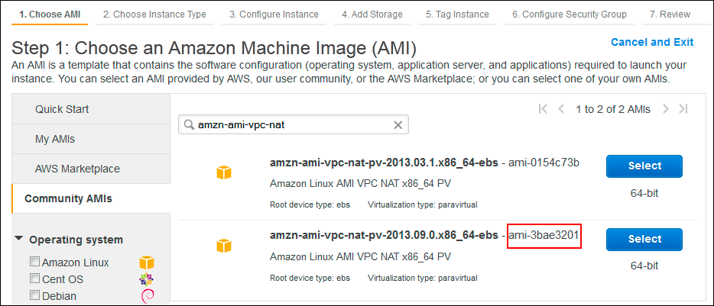

**NAT AMI**

This AMI is using paravirtual virtualization so it won’t work with t2.micro instance type. We will use the t1.micro instance type.

The following playbook will launch a NAT instance in the public subnet of our VPC and associate an Elastic IP address to the instance.

$ vi nat_launch.yml

³⁵<http://docs.aws.amazon.com/AmazonVPC/latest/UserGuide/VPC_NAT_Instance.html>

1. ---
2. - hosts: localhost
3. connection: local
4. gather_facts: no
5. vars_files:
6. - staging_vpc_info
7. vars:
8. region: ap-southeast-2
9. key: yan-key-pair-apsydney
10. instance_type: t1.micro
11. image: ami-3bae3201
12. prefix: staging
13. tasks:
14. - name: NAT instance provisioning
15. ec2:
16. region: "{{ region }}"
17. key_name: "{{ key }}"
18. instance_type: "{{ instance_type }}"
19. image: "{{ image }}"
20. wait: yes
21. group: "{{ prefix }}_sg_nat"
22. instance_tags:
23. Name: "{{ prefix }}_nat"
24. class: nat
25. environment: staging
26. id: nat_launch_01
27. vpc_subnet_id: "{{ staging_subnet_public }}"
28. source_dest_check: no
29. wait: yes
30. register: ec2
31. - name: associate new EIP for the instance
32. tags: eip
33. ec2_eip:
34. region: "{{ region }}"
35. instance_id: "{{ item.id }}"
36. with_items: ec2.instances
37. when: item.id is defined

Run the playbook and check your AWS EC2 console. A new staging_nat instance should be created in staging_subnet_public subnet and associated with an EIP address.

Each EC2 instance performs source/destination checks by default. This means that the instance must be the source or destination of any traffic it sends or receives. However, a NAT instance must be able

to send and receive traffic when the source or destination is not itself. Therefore, you must disable source/destination checks on the NAT instance. To do this, in the playbook we set the ec2 module’s option source_dest_check: no.

To allow instances in private subnet to connect to the Internet via the NAT instance, we must update the Main route tables. We need to do this from the AWS VPC console:

* 1. In the VPC console navigation pane select **Route tables**.
  2. Select the Main route table of your staging_vpc VPC and select the **Routes** tab.

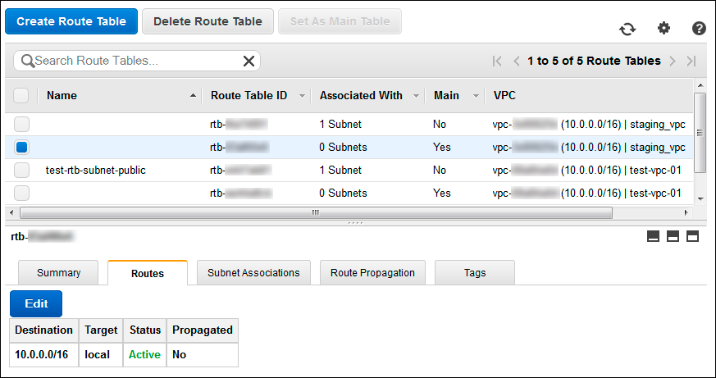

* 1. Click **Edit**
  2. Enter 0.0.0.0/0 CIDR block in the **Destination** field and select the staging_nat instance id from the **Target** list.

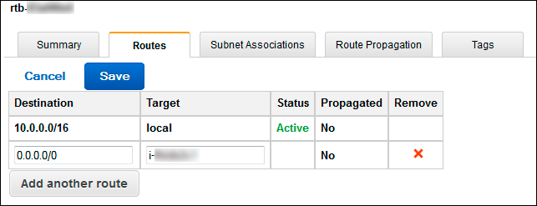

* 1. Click **Save**

Now we have completed the VPC infrastructure provisioning using Ansible. At the time of writing, there is not yet a module for *Network ACLs* provisioning. If you want to add some Network ACLs for your VPC subnet, you could do it from the VPC console: select **Network ACLs** in the navigation pane and then click **Create Network ACLs**. You can find more information about ACLs here: [http:](http://docs.aws.amazon.com/AmazonVPC/latest/UserGuide/VPC_ACLs.html)

[//docs.aws.amazon.com/AmazonVPC/latest/UserGuide/VPC_ACLs.html](http://docs.aws.amazon.com/AmazonVPC/latest/UserGuide/VPC_ACLs.html).

If you have finished with the examples, you can terminate the EC2 instances to avoid any cost.

## Multi-AZ Deployment

You can span your Amazon VPC across multiple subnets in multiple Availability Zones (AZ) inside a region. This will create a high availability system, adding redundancy to the system so that failure of a component does not mean failure of the entire system.

The following diagram shows a Multi-AZ version of our public and private subnets scenario. We’ll add a public subnet and a private subnet in another availability zone within our region.

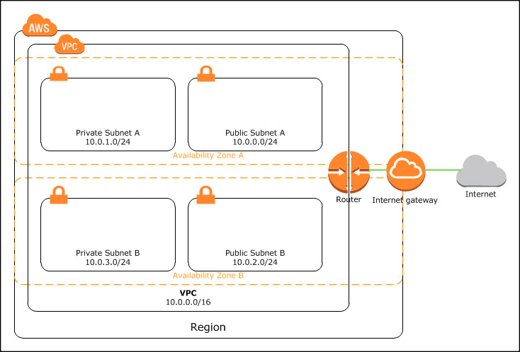

**Multi-AZ VPC**

We will use Ansible to provision our Multi-AZ VPC. First, we need to delete the staging_vpc VPC. You can use vpc_delete.yml to delete the VPC or you can delete the VPC from your AWS VPC console. Make sure you have terminated all EC2 instances in the VPC before deleting the VPC.

The following playbook will create a VPC with Multi-AZ subnets.

$ cd /home/yan/ansible4aws

$ vi vpc_create_multi_az.yml

1. ---
2. - hosts: localhost
3. connection: local
4. gather_facts: no
5. vars:
6. region: ap-southeast-2
7. # prefix for naming
8. prefix: staging
9. # availability zones
10. az0: ap-southeast-2a
11. az1: ap-southeast-2b
12. tasks:
13. - name: create vpc with multi-az subnets
14. ec2_vpc:
15. region: "{{ region }}"
16. cidr_block: 10.0.0.0/16
17. resource_tags: '{"Name":"{{ prefix }}_vpc"}'
18. subnets:

19 - cidr: 10.0.0.0/24

1. az: "{{ az0 }}"
2. resource_tags: '{"Name":"{{ prefix }}_subnet_public_0"}'

22 - cidr: 10.0.1.0/24

1. az: "{{ az0 }}"
2. resource_tags: '{"Name":"{{ prefix }}_subnet_private_0"}'

25 - cidr: 10.0.2.0/24

1. az: "{{ az1 }}"
2. resource_tags: '{"Name":"{{ prefix }}_subnet_public_1"}'

28 - cidr: 10.0.3.0/24

1. az: "{{ az1 }}"
2. resource_tags: '{"Name":"{{ prefix }}_subnet_private_1"}'
3. internet_gateway: yes
4. route_tables:
5. - subnets:

34 - 10.0.0.0/24

35 - 10.0.2.0/24

36 routes:

37 - dest: 0.0.0.0/0

1. gw: igw
2. register: vpc
3. - name: write vpc id to {{ prefix }}_vpc_info file
4. shell: echo "{{ prefix }}"_vpc":" "{{ vpc.vpc_id }}"
5. > "{{ prefix }}"_vpc_info
6. - name: write subnets id to {{ prefix }}_vpc_info file
7. shell: echo "{{ item.resource_tags.Name }}"":" "{{ item.id }}"
8. >> "{{ prefix }}"_vpc_info
9. with_items: vpc.subnets

After running the playbook, a new VPC will be created, with 2 subnets in ap-southeast-2a zone, named staging_subnet_private_0 and staging_subnet_public_0, and 2 subnets in ap- southeast-2b zone, named staging_subnet_private_1 and staging_subnet_public_1.

Run sg_empty.yml playbook, and then sg_modify.yml playbook to re-create our VPC security groups.

To achieve high availability, you can deploy your web application cluster in 2 (or more) availability zones (staging_subnet_public_0 and staging_subnet_public_1), and distribute the load using Amazon Elastic Load Balancing (ELB). For the database tier, you can use Amazon RDS (Relational Database Service), deployed in 2 (or more) availability zones (staging_subnet_private_0 and staging_subnet_private_1).

## Ansible in VPC

Instances in private subnet of a VPC cannot directly receive inbound traffic from the internet. Therefore you can’t use Ansible from the internet to manage the private server configuration. To use Ansible to manage configuration of servers in the private subnet of a VPC, we have 2 options:

* + Install Ansible in an instance in public subnet of the VPC and allow SSH connection from the Ansible machine to the hosts to be managed in private subnet. This Ansible machine can also be used as a *jump box* to allow SSH access from the internet to hosts in private subnet (SSH to the Ansible machine first and then use the Ansible machine to SSH to hosts in private subnet).

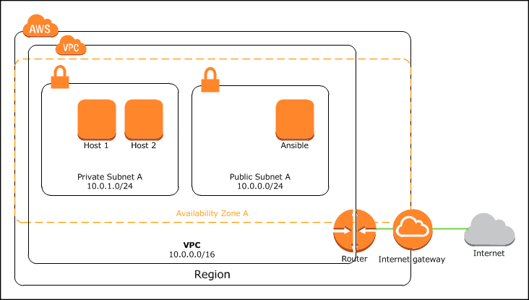

* + Create a VPN (Virtual Private Network) connection between Ansible machine (over the internet) and the private subnet. We can launch an OpenVPN server (available in AWS marketplace) instance in the public subnet which will allow Ansible machine to log in using OpenVPN client and connect via SSH to hosts in the private subnet.

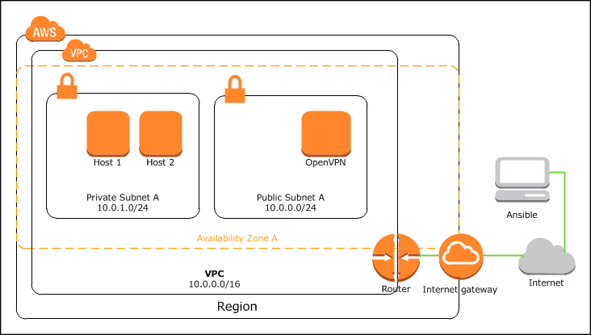

We can use our current Ansible machine to launch a *jump box* instance in the public subnet and install Ansible on the instance. First, we need to create a new security group for this instance.

The following playbook will create a new security group for the Ansible or jump box instance:

$ cd /home/yan/ansible4aws

$ vi sg_jumpbox.yml

1. ---
2. - hosts: localhost
3. connection: local
4. gather_facts: no
5. vars_files:
6. - staging_vpc_info
7. vars:
8. #your region
9. region: ap-southeast-2
10. #your ip address
11. allowed_ip: 123.xxx.xxx.xxx/32
12. #prefix for naming
13. prefix: staging
14. vpc_id: "{{ staging_vpc }}"
15. tasks:
16. - name: create security group for jump box instance
17. ec2_group:
18. region: "{{ region }}"
19. vpc_id: "{{ vpc_id }}"
20. #your security group name
21. name: "{{ prefix }}_sg_jumpbox"
22. description: security group for jump box
23. rules:
24. # allow ssh access from your ip address
25. - proto: tcp
26. from_port: 22
27. to_port: 22
28. cidr_ip: "{{ allowed_ip }}"
29. rules_egress:
30. - proto: all

31 cidr_ip: 0.0.0.0/0

$ ansible-playbook -i hosts sg_jumpbox.yml

The following playbook will launch our jump box instance in public subnet A:

$ vi ec2_vpc_jumpbox.yml

* 1. ---
  2. - hosts: localhost
  3. connection: local
  4. gather_facts: no
  5. vars_files:
  6. - staging_vpc_info
  7. vars:
  8. region: ap-southeast-2
  9. key: yan-key-pair-apsydney
  10. instance_type: t2.micro
  11. image: ami-d9fe9be3
  12. prefix: staging
  13. vpc_subnet_id: "{{ staging_subnet_public_0 }}"
  14. tasks:
  15. - name: jump box instance provisioning
  16. ec2:
  17. region: "{{ region }}"
  18. key_name: "{{ key }}"
  19. instance_type: "{{ instance_type }}"
  20. image: "{{ image }}"
  21. wait: yes
  22. group: "{{ prefix }}_sg_jumpbox"
  23. instance_tags:
  24. Name: "{{ prefix }}_jumpbox"
  25. class: jumpbox
  26. environment: "{{ prefix }}"
  27. id: jumpbox_launch_01
  28. vpc_subnet_id: "{{ vpc_subnet_id }}"
  29. register: ec2
  30. - name: associate new EIP for the instance
  31. ec2_eip:
  32. region: "{{ region }}"
  33. instance_id: "{{ item.id }}"
  34. with_items: ec2.instances

Ping the instance, make sure Ansible can connect via SSH to the host:

$ ansible -i ec2.py tag_class_jumpbox -m ping

You might want to disable host key checking in ssh configuration so ssh will automatically add new host keys to the user known hosts files without asking (the default is “ask”). To disable host key checking, set StrictHostKeyChecking no in your /etc/ssh/ssh_config file.

Create roles to install Ansible:

# mkdir roles/ansible

# mkdir roles/ansible/tasks

$ vi roles/ansible/tasks/main.yml

* + 1. ---
    2. - name: upgrade all packages
    3. yum: name=* state=latest
    4. - name: install the 'Development tools' package group
    5. yum: name="@Development tools" state=present
    6. - name: install required packages
    7. yum: name={{ item }} state=present
    8. with_items:
    9. - epel-release.noarch
    10. - python-pip
    11. - python-devel
    12. - name: install setuptools
    13. pip: name=setuptools extra_args='--upgrade'
    14. - name: install ansible
    15. pip: name=ansible

And the playbook to install Ansible in the jump box instance:

$ vi install_ansible.yml

* + - 1. ---
      2. - hosts: tag_class_jumpbox
      3. become: yes
      4. roles:
      5. - ansible

$ ansible-playbook -i ec2.py install_ansible.yml

To allow SSH access from this new Ansible machine, do not forget to modify the security group of hosts you want to manage. For example if you want to install your own MySQL database server in the private subnet and manage the configuration using Ansible, you can modify the rules in sg_modify.yml:

- name: modify sg_database rules ec2_group:

region: "{{ region }}"

vpc_id: "{{ vpc_id }}"

name: "{{ prefix }}_sg_database" description: security group for databases rules:

# allow ssh from the jump box

* proto: tcp from_port: 22

to_port: 22

group_name: "{{ prefix }}_sg_jumpbox" # allow mysql access from web servers

* proto: tcp from_port: 3306

to_port: 3306

group_name: "{{ prefix }}_sg_web" rules_egress:

* proto: tcp from_port: 80

to_port: 80 cidr_ip: 0.0.0.0/0

* proto: tcp

from_port: 443

to_port: 443 cidr_ip: 0.0.0.0/0

And run the sg_modify.yml playbook to modify security group rules.

## OpenVPN Server

This section will show you how to launch an OpenVPN EC2 instance in the public subnet using Ansible, and configure the server from its web UI.

OpenVPN Access Server is a full featured SSL VPN software solution that integrates OpenVPN server capabilities, enterprise management capabilities, simplified OpenVPN Connect UI, and Open- VPN Client software packages that accommodate Windows, MAC, and Linux OS environments. OpenVPN Access Server supports a wide range of configurations, including secure and granular remote access to internal network and/ or private cloud network resources and applications with fine-grained access control.³⁶

To launch an OpenVPN instance, first we need to know the AMI ID of the OpenVPN Access Server AMI for our region.

To get the AMI ID:

1. Go to your EC2 dashboard, select your region, and then click **Launch Instance** button.
2. On the left hand navigation bar, select **Community AMIs**.
3. When the AMI selection dialog appears, type **OpenVPN** in the search box.
4. 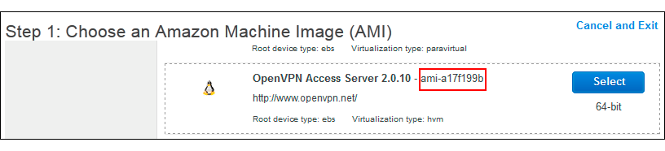Locate the latest version of OpenVPN Access Server AMI provided by openvpn.net and note the AMI ID.
5. Select **Cancel and Exit**.

Create the security group for our OpenVPN server:

$ vi sg_openvpn.yml

³⁶<http://openvpn.net/index.php/access-server/overview.html>

1. ---
2. - hosts: localhost
3. connection: local
4. gather_facts: no
5. vars_files:
6. - staging_vpc_info
7. vars:
8. #your region
9. region: ap-southeast-2
10. #your ip address
11. allowed_ip: 123.xxx.xxx.xxx/32
12. #prefix for naming
13. prefix: staging
14. vpc_id: "{{ staging_vpc }}"
15. tasks:
16. - name: create security group for openvpn instance
17. ec2_group:
18. region: "{{ region }}"
19. vpc_id: "{{ vpc_id }}"
20. #your security group name
21. name: "{{ prefix }}_sg_openvpn"
22. description: security group for openvpn
23. rules:
24. - proto: tcp
25. from_port: 22
26. to_port: 22
27. cidr_ip: "{{ allowed_ip }}"
28. - proto: tcp
29. from_port: 443
30. to_port: 443
31. cidr_ip: 0.0.0.0/0
32. - proto: tcp
33. from_port: 943
34. to_port: 943
35. cidr_ip: 0.0.0.0/0
36. - proto: udp
37. from_port: 1194
38. to_port: 1194
39. cidr_ip: 0.0.0.0/0
40. rules_egress:
41. - proto: all

42 cidr_ip: 0.0.0.0/0

Run the playbook:

$ ansible-playbook -i hosts sg_openvpn.yml

The following playbook will launch our OpenVPN server instance in public subnet A:

$ vi ec2_vpc_openvpn.yml

* 1. ---
  2. - hosts: localhost
  3. connection: local
  4. gather_facts: no
  5. vars_files:
  6. - staging_vpc_info
  7. vars:
  8. region: ap-southeast-2
  9. key: yan-key-pair-apsydney
  10. instance_type: t2.micro
  11. image: ami-a17f199b
  12. prefix: staging
  13. vpc_subnet_id: "{{ staging_subnet_public_0 }}"
  14. tasks:
  15. - name: openvpn server instance provisioning
  16. ec2:
  17. region: "{{ region }}"
  18. key_name: "{{ key }}"
  19. instance_type: "{{ instance_type }}"
  20. image: "{{ image }}"
  21. source_dest_check: no
  22. wait: yes
  23. group: "{{ prefix }}_sg_openvpn"
  24. instance_tags:
  25. Name: "{{ prefix }}_openvpn"
  26. class: openvpn
  27. environment: "{{ prefix }}"
  28. id: openvpn_launch_01
  29. vpc_subnet_id: "{{ vpc_subnet_id }}"
  30. register: ec2
  31. - name: associate new EIP for the instance
  32. ec2_eip:
  33. region: "{{ region }}"
  34. instance_id: "{{ item.id }}"
  35. with_items: ec2.instances

### Configure OpenVPN Server

To configure, SSH to the OpenVPN Access Server as openvpnas user:

# ssh -i ∼/.ssh/yan-key-pair-apsydney.pem openvpnas@*openvpn-ipaddress*

The OpenVPN Access Server Setup Wizard runs automatically upon your initial login to the appliance. If you would like to run this wizard again in the future, issue the become ovpn-init

--ec2 command in the terminal.

>Please enter 'yes' to indicate your agreement [no]: yes Will this be the primary Access Server node?

(enter 'no' to configure as a backup or standby node)

* Press ENTER for default [yes]:

Please specify the network interface and IP address to be used by the Admin Web UI:

* + 1. all interfaces: 0.0.0.0
    2. eth0: 10.0.0.40

Please enter the option number from the list above (1-2).

* + - * Press Enter for default [2]: 1

Please specify the port number for the Admin Web UI.

* + - * Press ENTER for default [943]:

Please specify the TCP port number for the OpenVPN Daemon

* + - * Press ENTER for default [443]:

Should client traffic be routed by default through the VPN?

* + - * Press ENTER for default [no]:

Should client DNS traffic be routed by default through the VPN?

* + - * Press ENTER for default [no]:

Use local authentication via internal DB?

* + - * Press ENTER for default [yes]:

Private subnets detected: ['10.0.0.0/16']

Should private subnets be accessible to clients by default?

* + - * Press ENTER for EC2 default [yes]:

To initially login to the Admin Web UI, you must use a username and password that successfully authenticates you with the host UNIX system (you can later modify the settings so that RADIUS or LDAP is used for authentication instead).

You can login to the Admin Web UI as "openvpn" or specify a different user account to use for this purpose.

Do you wish to login to the Admin UI as "openvpn"?

* + - * Press ENTER for default [yes]: no

>Specify the username for an existing user or for the new user account: openvpn-\ admin

>Type the password for the 'openvpn-admin' account:

>Confirm the password for the 'openvpn-admin' account:

>Please specify your OpenVPN-AS license key (or leave blank to specify later):

Initializing OpenVPN...

After you complete the setup wizard, you can access the Admin Web UI area to configure other aspects of your VPN:

1. Go to https://*openvpn-ipaddress*/admin‘.
2. Go to **VPN Settings** menu.
3. Configure subnets for the clients. On the Dynamic IP Address network allocate address for VPN clients, for example 10.1.0.0/23.

Static IP Address Network: (leave empty)

Group Default IP Address Network: (leave empty)

1. Click **Save settings**.
2. Click **Update Running Server**.

To add user:

1. Go to **User Permissions** menu.
2. Add a user name.
3. Click **show** and set password.
4. Click **Update Running Server**.

### Connect Client

The Connect Client can be accessed via a preferred web browser by entering the following address into the address bar: https://*openvpn-ipaddress*.

Users have the option to either Connect to the VPN or Login to the Connect Client. When connecting, the user will be connected to the VPN directly through their web browser. When the user decides to login to the Connect Client they can download their user configuration files (client.ovpn) and use them to connect to the VPN with other OpenVPN Clients.

For more information on OpenVPN Access Server go to [https://openvpn.net/index.php/access-](https://openvpn.net/index.php/access-server/docs.html) [server/docs.html](https://openvpn.net/index.php/access-server/docs.html).

## Getting VPC and Subnet ID

One reader told me that it’s horrible to store VPC and subnets ID in a file. Too bad Ansible doesn’t have a module yet to get the VPC or subnets ID based on particular filter. This following Python script can be added as Ansible module and called from playbook, to get the VPC or subnet ID based on resource tags. Of course when you created the VPC or subnets you have to give a spesific tag for each resource to make this module works. This will also give you an example on how to add your own Ansible module. The output of this module is in JSON format { vpc_ids: [list of vpc ids], subnet_ids: [list of subnet ids] }.

The original code can be found here: [https://github.com/edx/configuration/blob/master/playbooks/](https://github.com/edx/configuration/blob/master/playbooks/library/vpc_lookup) [library/vpc_lookup](https://github.com/edx/configuration/blob/master/playbooks/library/vpc_lookup). I modified some parts of the code to make it work.

Put the following script in library/ directory, relative to your playbook.

$ cd /home/yan/ansible4aws # mkdir library

$ vi library/vpc_lookup

1 #!/usr/bin/python

2

3 #author: John Jarvis 4

5 import sys

6

1. AWS_REGIONS = ['ap-northeast-1',
2. 'ap-southeast-1',
3. 'ap-southeast-2',
4. 'eu-west-1',
5. 'sa-east-1',
6. 'us-east-1',
7. 'us-west-1',
8. 'us-west-2']

15

1. try:
2. from boto.vpc import VPCConnection
3. from boto.vpc import connect_to_region
4. except ImportError:
5. print "failed=True msg='boto required for this module'"
6. sys.exit(1)

22

23 def main():

24

1. module=AnsibleModule(
2. argument_spec=dict(
3. region=dict(choices=AWS_REGIONS),
4. aws_secret_key=dict(aliases=['ec2_secret_key', 'secret_key'],
5. no_log=True),
6. aws_access_key=dict(aliases=['ec2_access_key', 'access_key']),
7. tags=dict(default=None, type='dict'),

32 )

33 )

34

1. tags = module.params.get('tags')
2. aws_secret_key = module.params.get('aws_secret_key')
3. aws_access_key = module.params.get('aws_access_key')
4. region = module.params.get('region') 39
5. # If we have a region specified, connect to its endpoint.
6. if region:
7. try:
8. vpc = connect_to_region(region, aws_access_key_id=aws_access_key,
9. aws_secret_access_key=aws_secret_key)
10. except boto.exception.NoAuthHandlerFound, e:
11. module.fail_json(msg=str(e))
12. else:
13. module.fail_json(msg="region must be specified") 49
14. subnet_ids = []
15. for tag, value in tags.iteritems():
16. for subnet in vpc.get_all_subnets(filters={"tag:" + tag: value}):
17. subnet_ids.append(subnet.id)

54

55 vpc_ids = []

56 for tag, value in tags.iteritems():

57 for vpc in vpc.get_all_vpcs(filters={"tag:" + tag: value}):

58 vpc_ids.append(vpc.id)

59

60 module.exit_json(changed=False, vpc_ids=vpc_ids, subnet_ids=subnet_ids) 61

62

63 # this is magic, see lib/ansible/module_common.py

64 #<<INCLUDE_ANSIBLE_MODULE_COMMON>>

65

66 main()

# chmod 755 library/vpc_lookup

The following playbook will show you how to use this additional module. This example playbook will get the ID of VPC with resource tags “Name=test-vpc” (if exists) and delete the VPC.

$ vi vpc_delete.yml

1. ---
2. - hosts: localhost
3. connection: local
4. gather_facts: no
5. vars:
6. region: ap-southeast-2
7. tasks:
8. - name: get vpc id
9. vpc_lookup:
10. region: "{{ region }}"
11. tags:
12. Name: test-vpc
13. register: vpc

14

1. - name: delete vpc
2. ec2_vpc:
3. region: "{{ region }}"
4. state: absent
5. vpc_id: "{{ item }}"
6. wait: yes
7. with_items: vpc.vpc_ids

You can use the same module to get subnet id based on resource tags, the JSON output used is

subnet_ids.

You can also use Ansible extra modules called ec2_vpc_net_facts and ec2_vpc_- subnet_facts (added in version 2.1) to gather VPC and subnet facts. For more infor- mation, go to <http://docs.ansible.com/ansible/ec2_vpc_net_facts_module.html> and [http:](http://docs.ansible.com/ansible/ec2_vpc_subnet_facts_module.html)

[//docs.ansible.com/ansible/ec2_vpc_subnet_facts_module.html](http://docs.ansible.com/ansible/ec2_vpc_subnet_facts_module.html).